**SDLC – Software Development Life Cycle:**

1. Systematic process for building Software

**Phases of SDLC:**

1. Requirement Analysis
2. Feasibility Study
   1. Economic – decide budget
   2. Legal – Follow Cyber law
   3. Operation Feasibility – can we meet client expectations
   4. Technical – Checking System Configuration
   5. Schedule – Project Can be completed in given deadline or not
3. Design – Overall System Architecture.
4. Start to write to code for Software
5. Testing – Start to test Software
6. Deployment – Installation of Software (Only when 5 is passed)
7. Maintenance – Bug Fixing, upgrade, enhancement

**Popular SDLC Models:**

1. Waterfall Model
2. Iterative Model
3. Spiral
4. Big Bang
5. Agile
6. RAD

**Waterfall Model:**

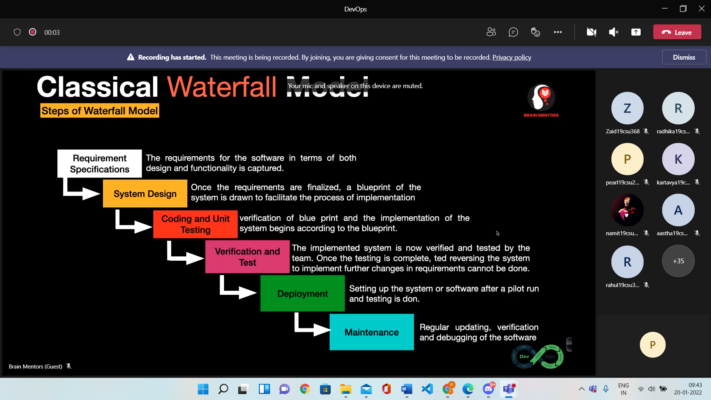

**Advantages**

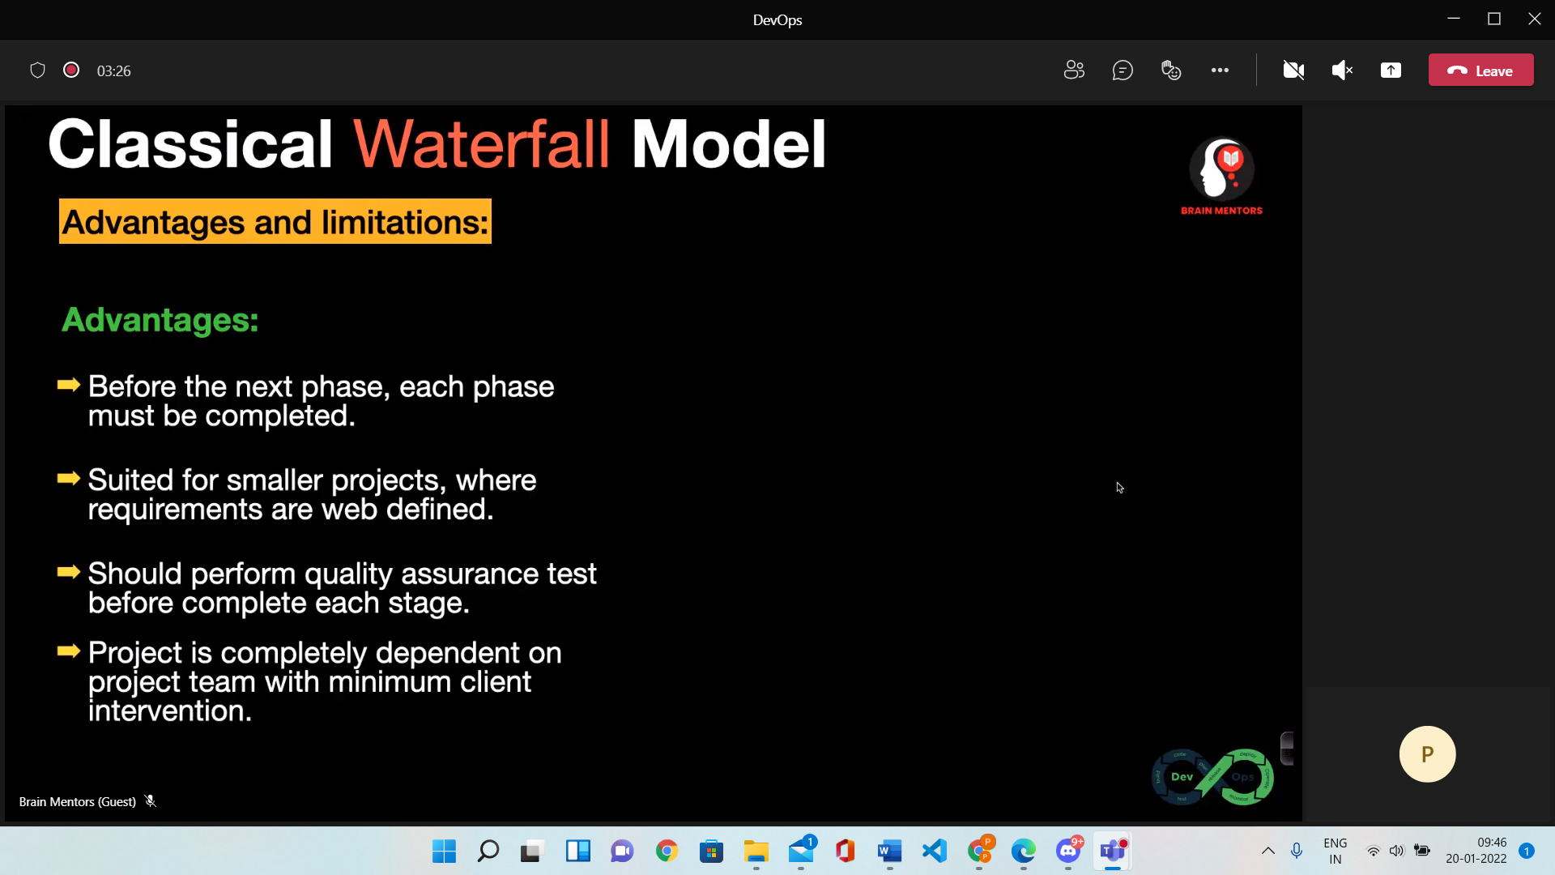

**Disadvantages**

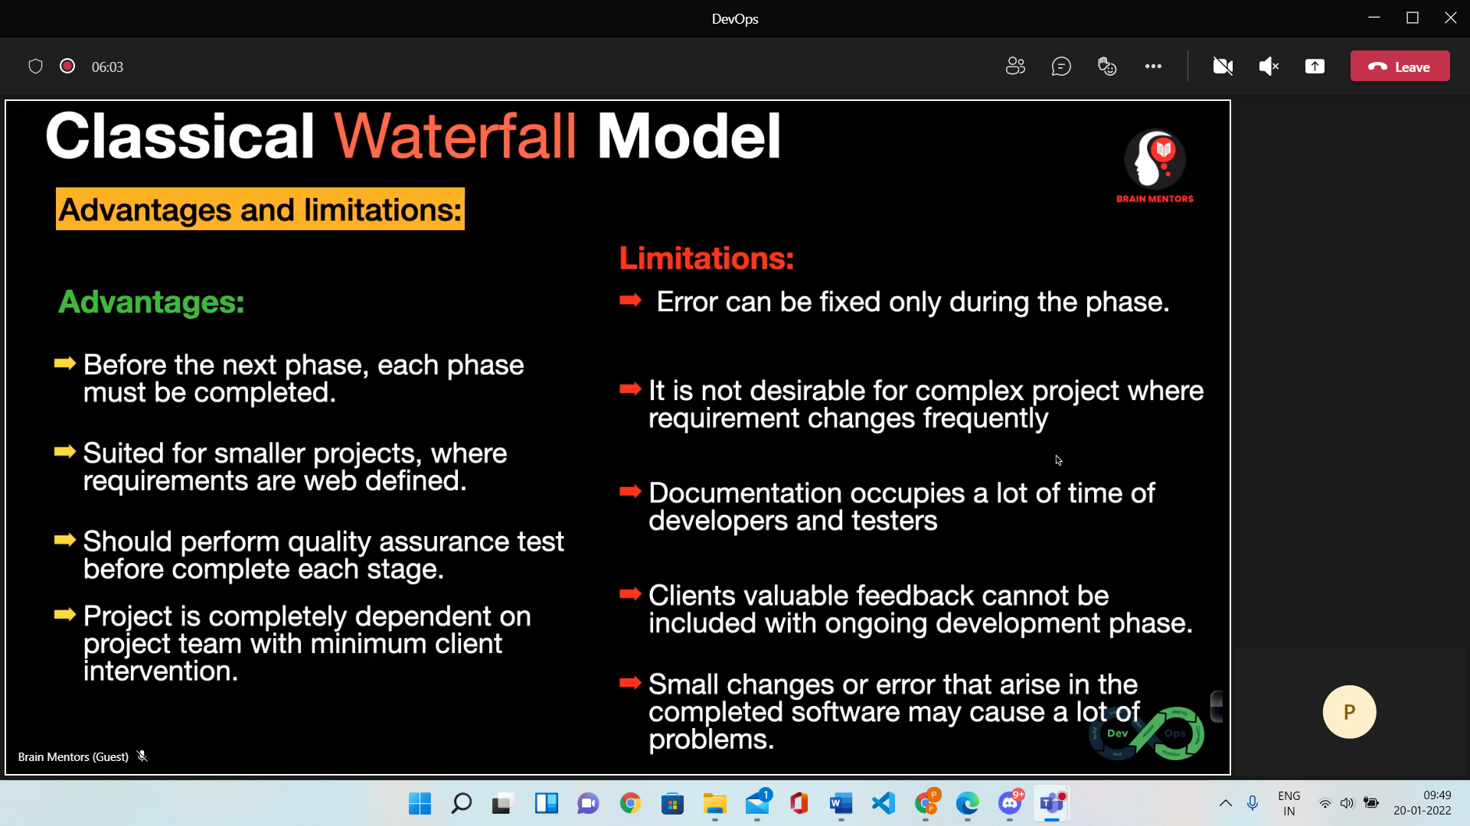

**Agile Model 🡪**

1.What is Agile

2.Agile Values and Principals

3.Pros and Cons

4.Agile vs Traditional SDLC (Waterfall)

Agile model

* Agile methodology – Combination of Iterative and incremental process
* It follows continuous Iteration of development and testing
* Both development and testing teams can work concurrently

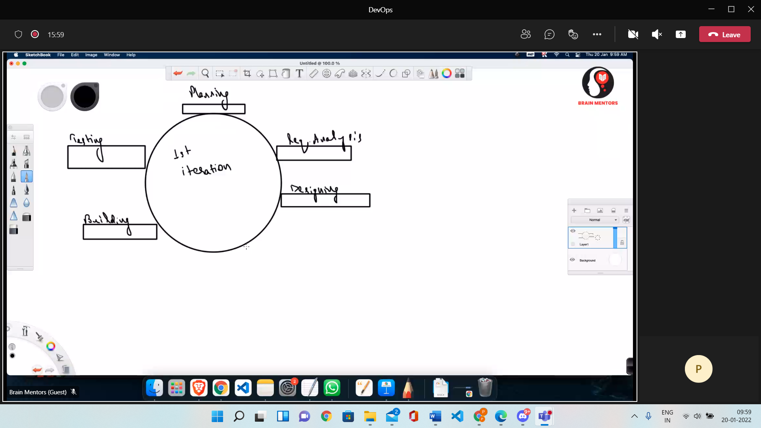

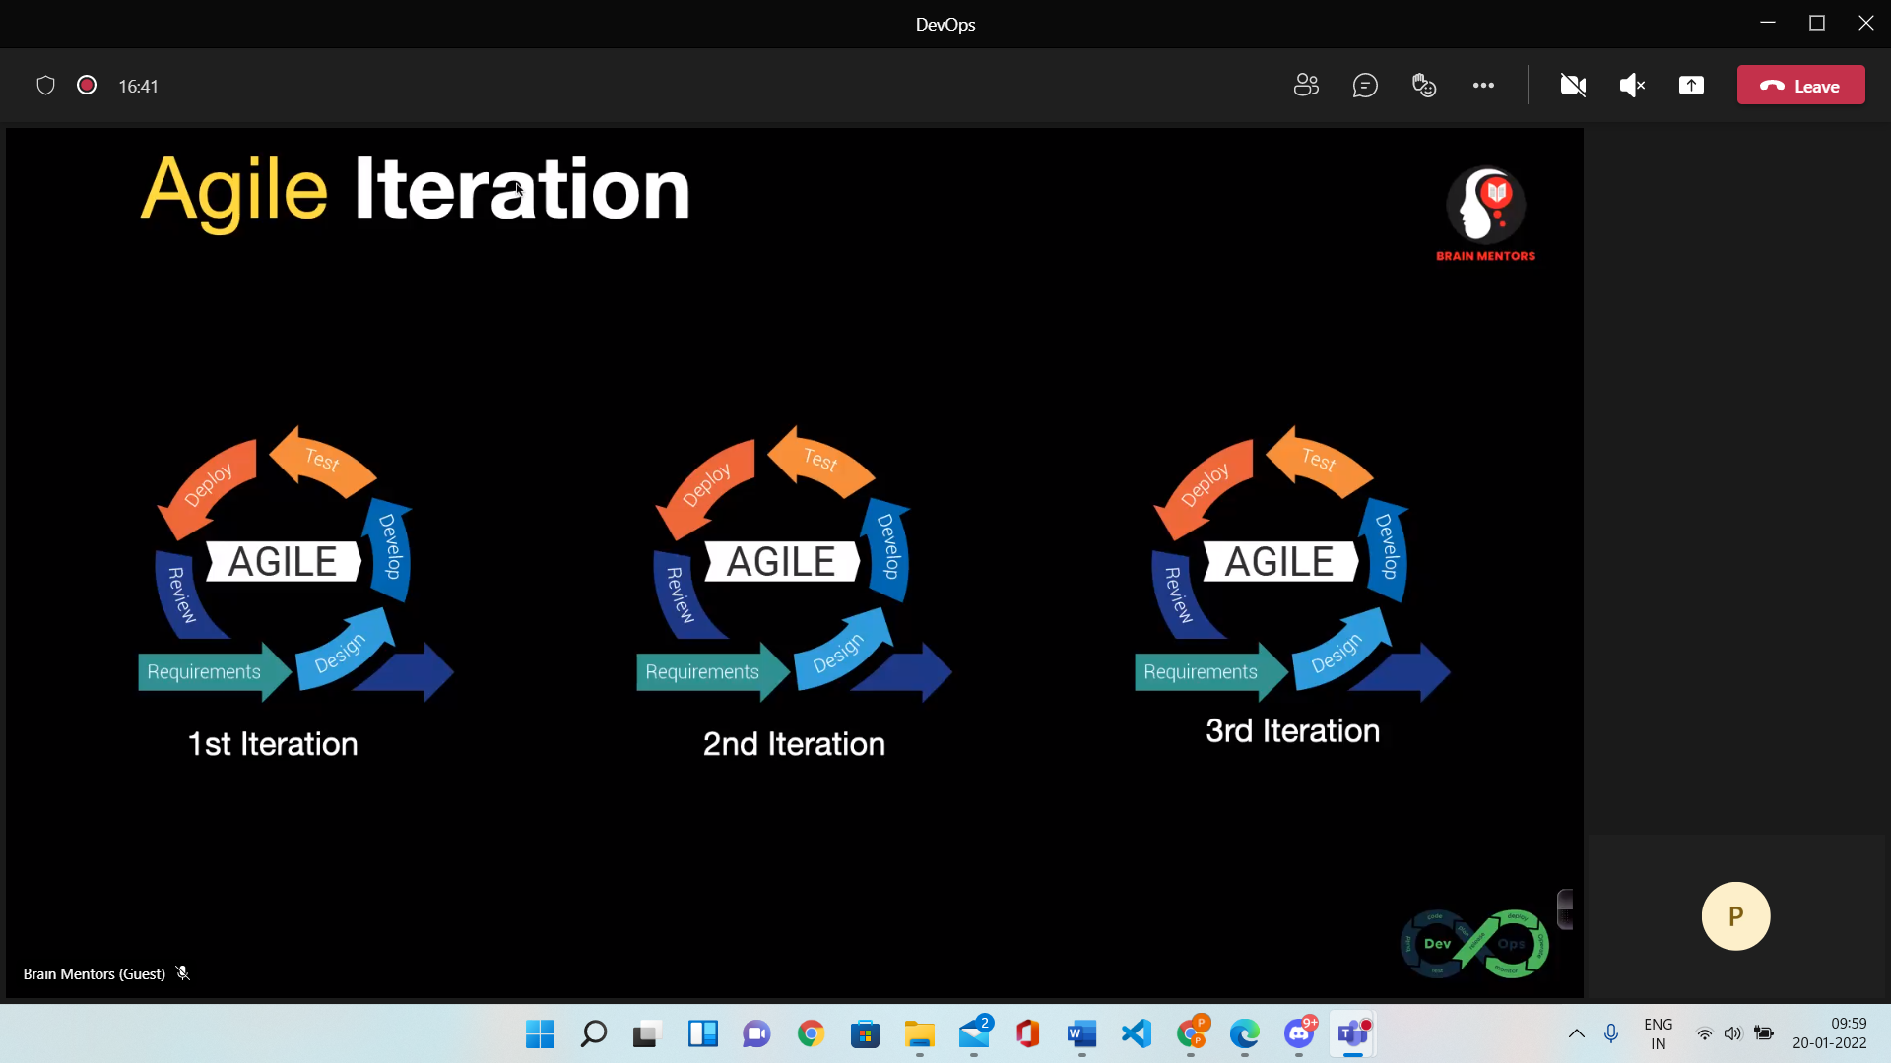

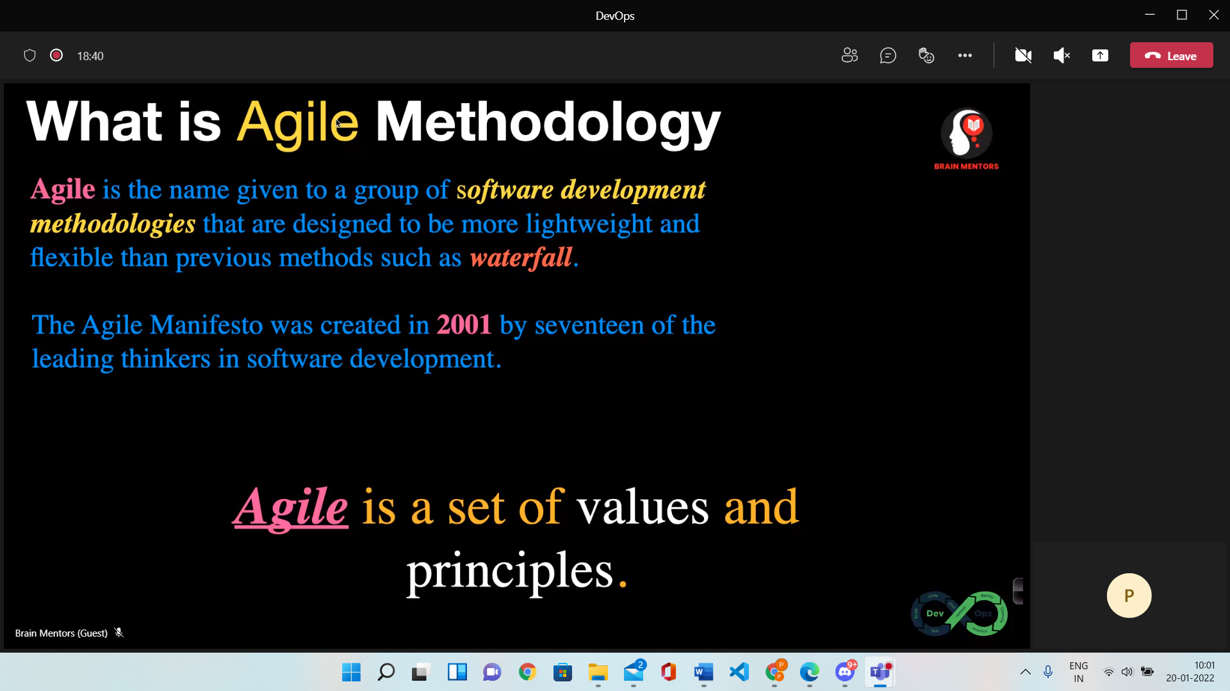

**Agile Principals 🡪**

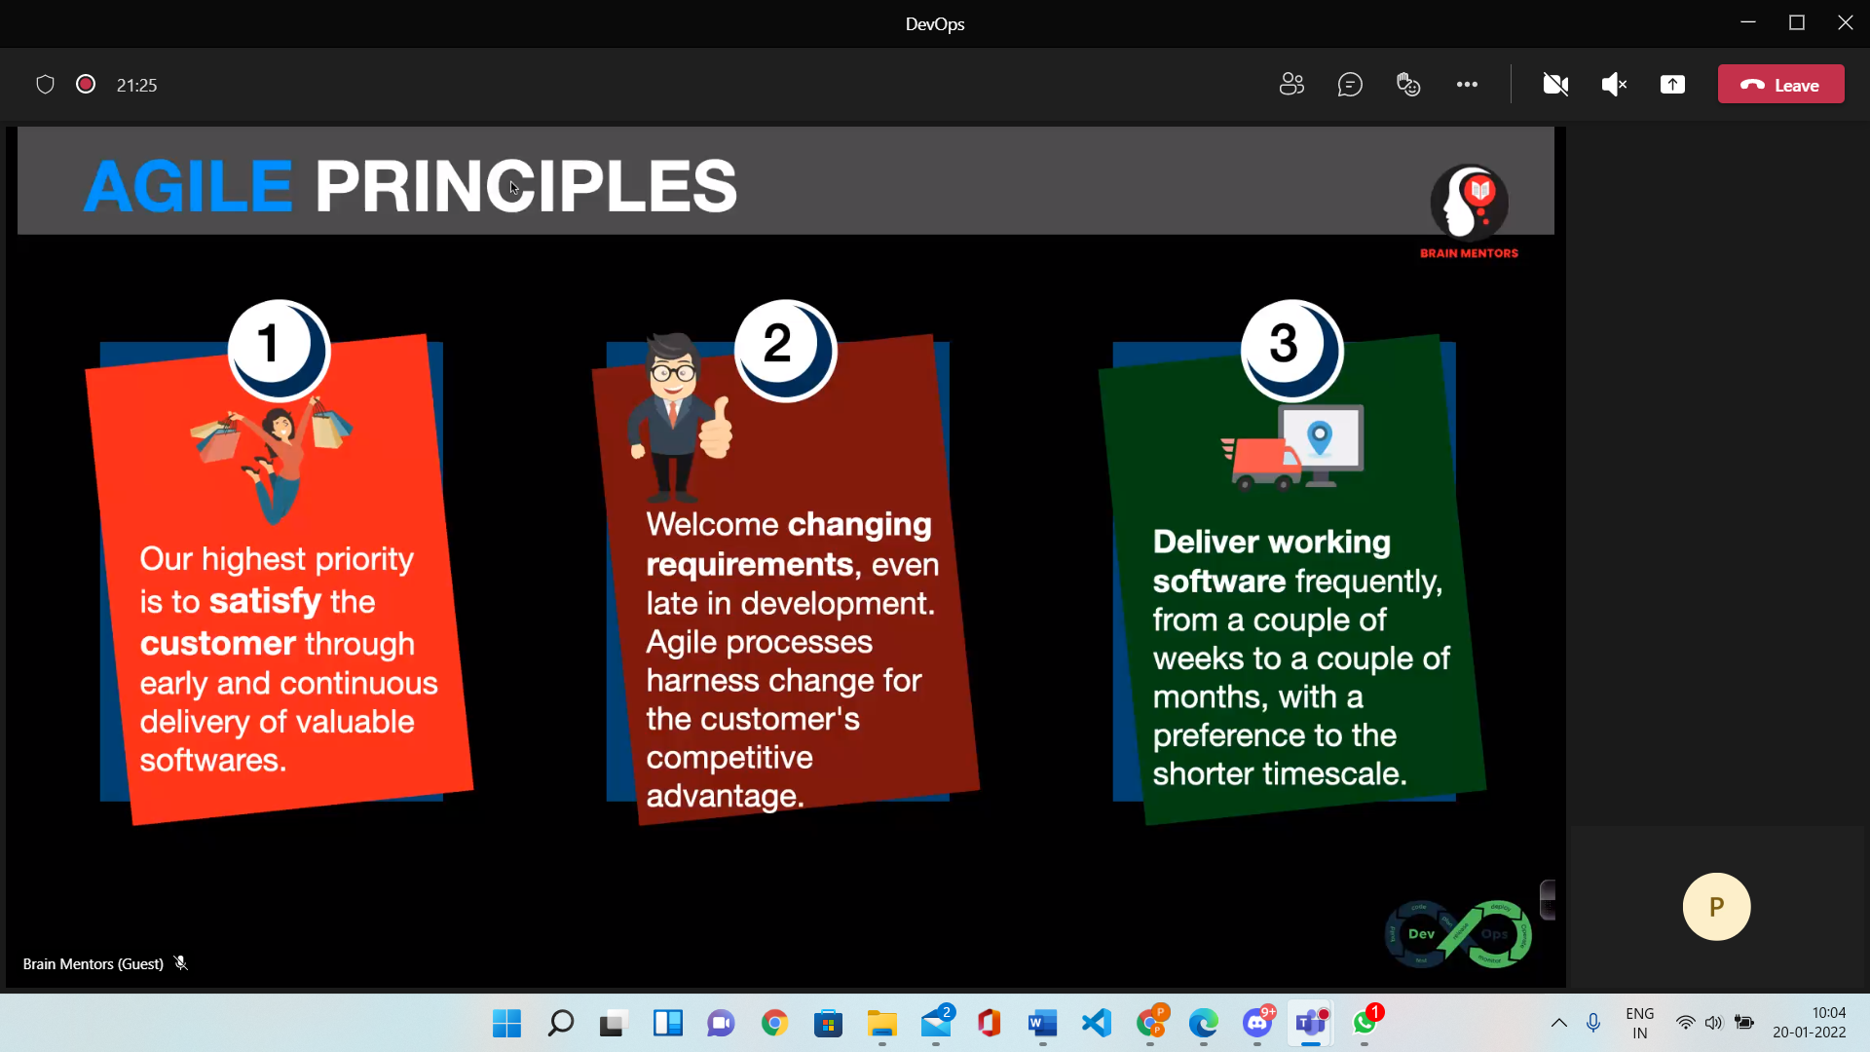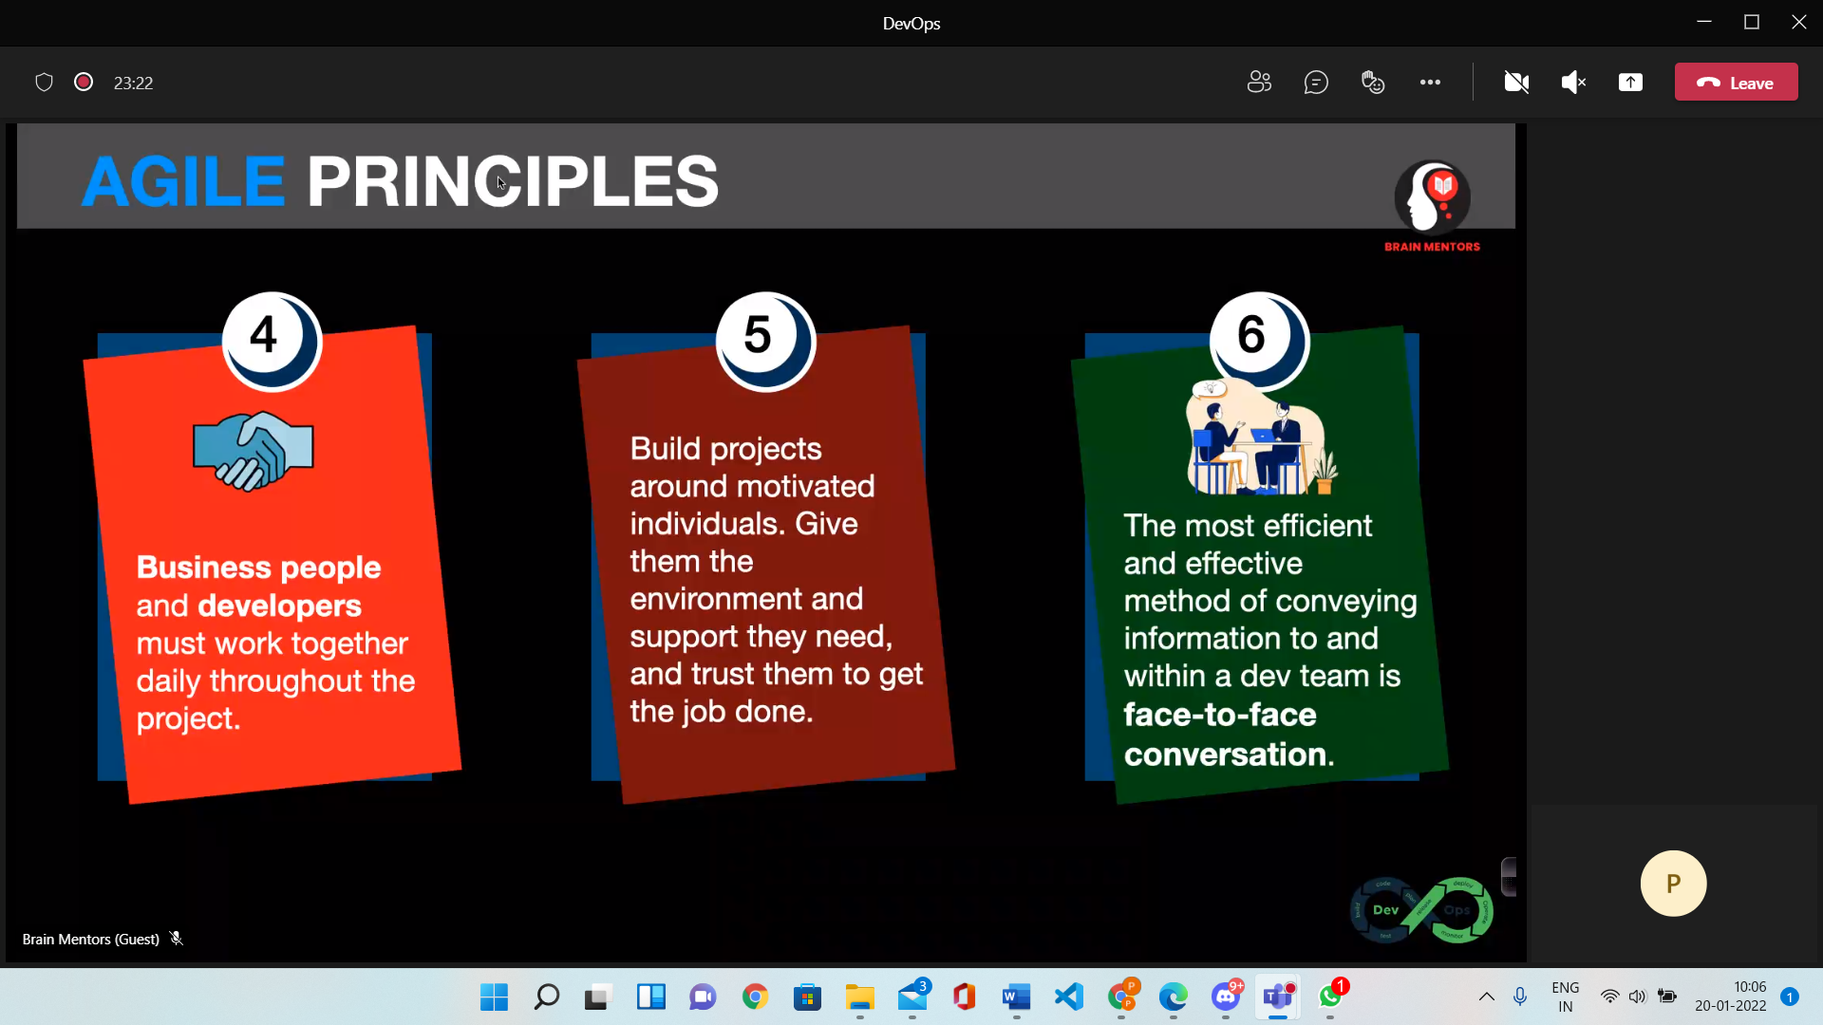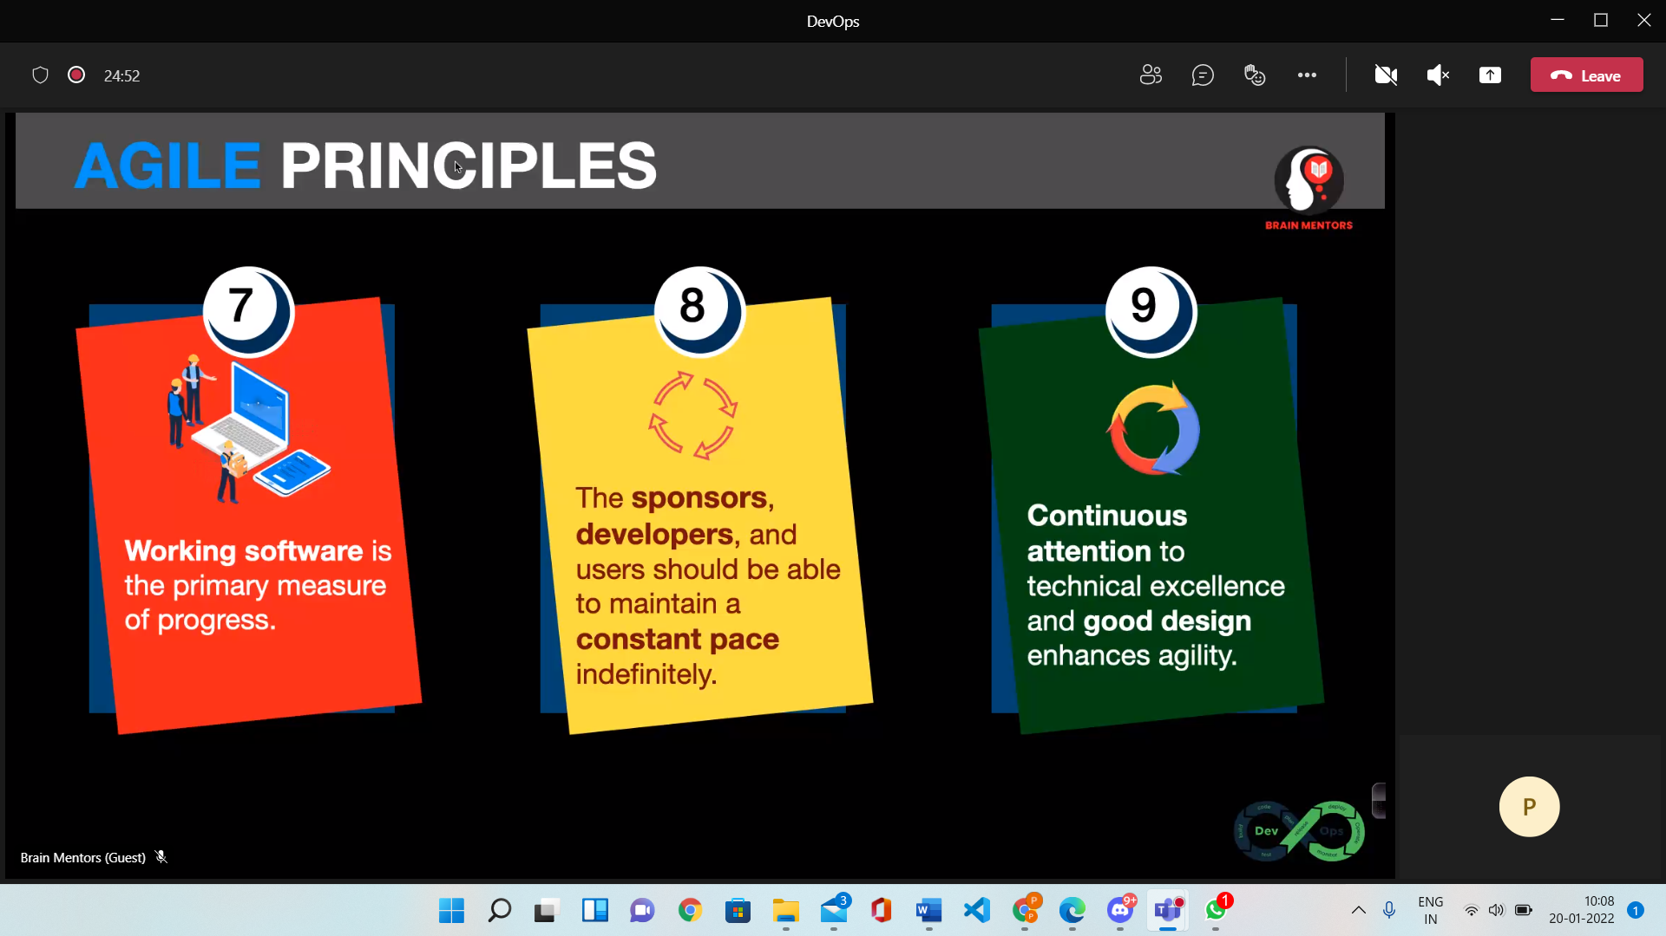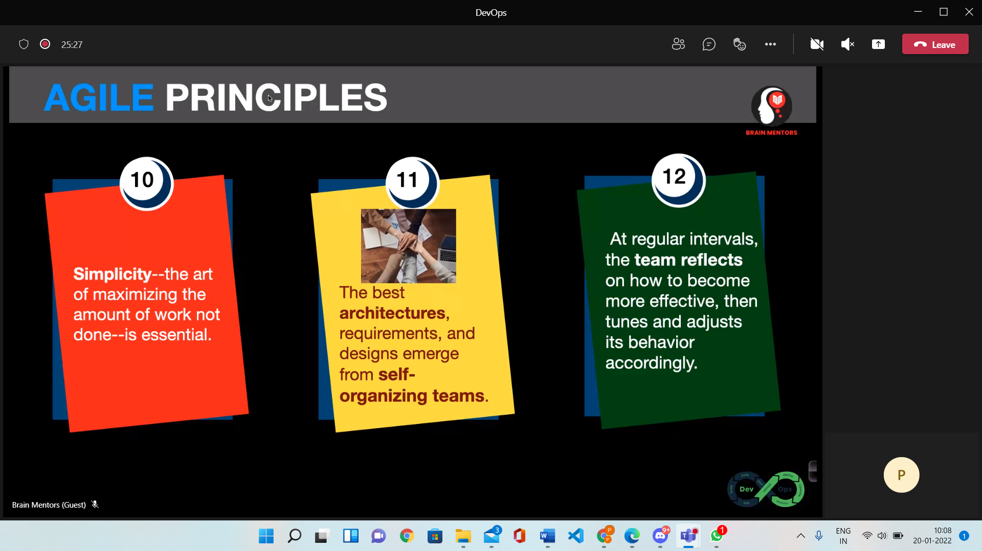

**Agile Methods 🡪**

1. Crystal Clear
2. SCRUM
   * SCRUM Master
   * Product Owner
   * SCRUM Team
3. DSDM – Dynamic Software Development Method
4. FDD – Feature Driven Development
5. Lean Software Development
6. Extreme Programming
   * Phase of Customer Delivery
   * No Ghar jaane ka time

**SCRUM** – Type of job

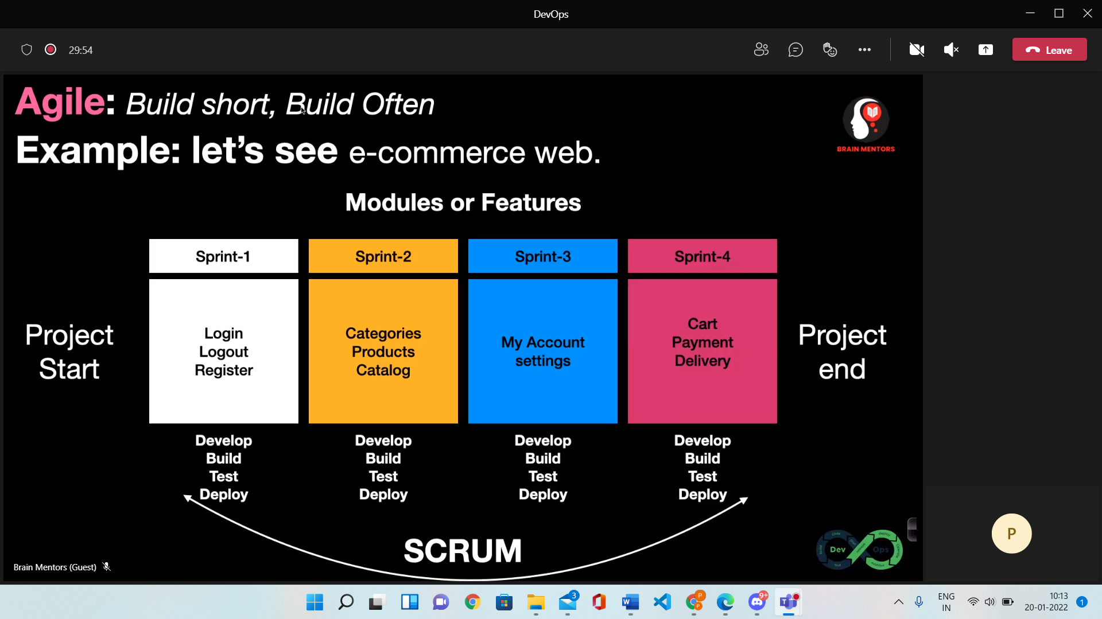

**Waterfall vs Agile**

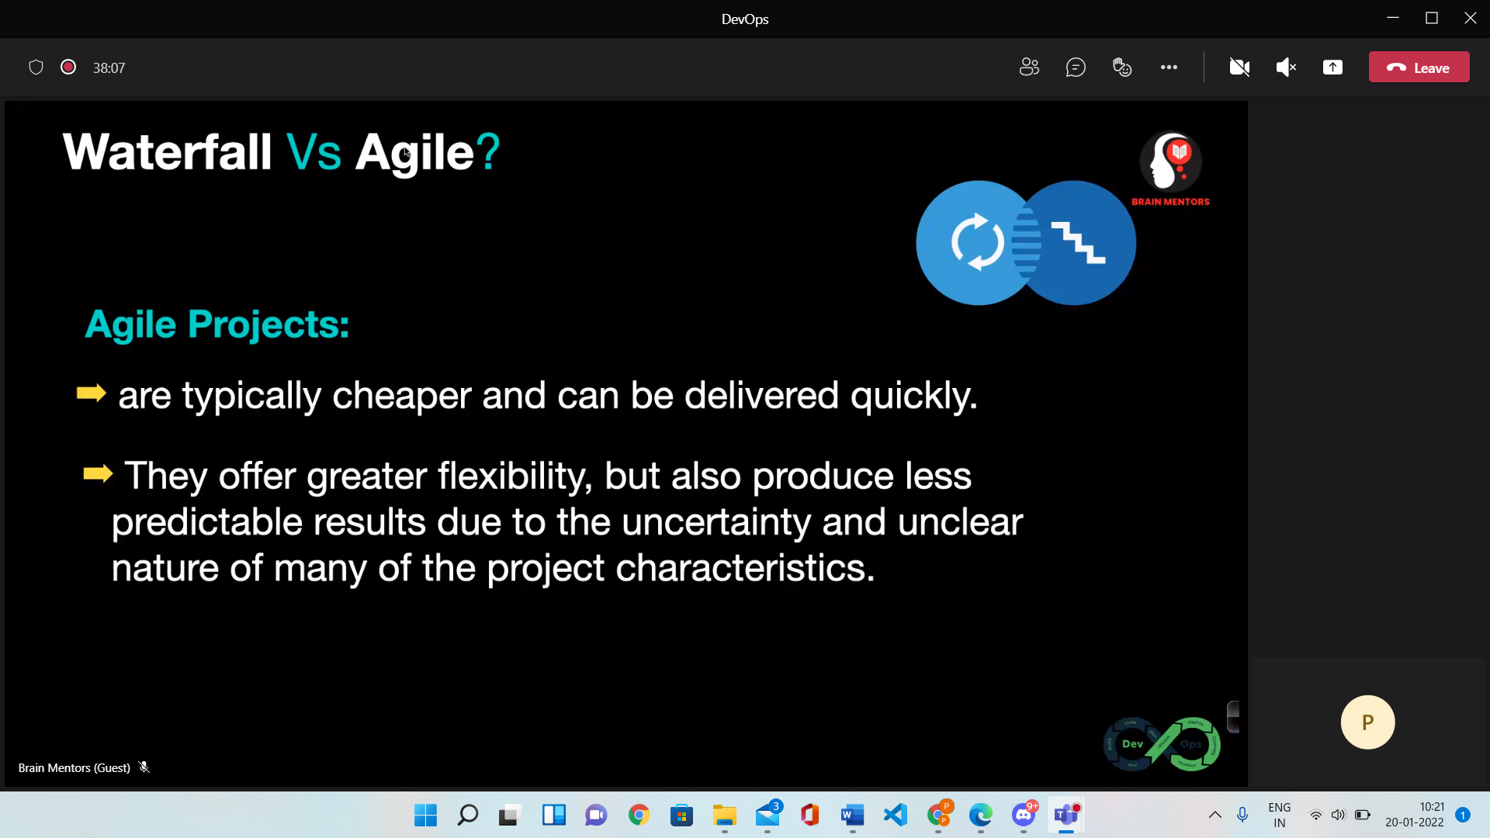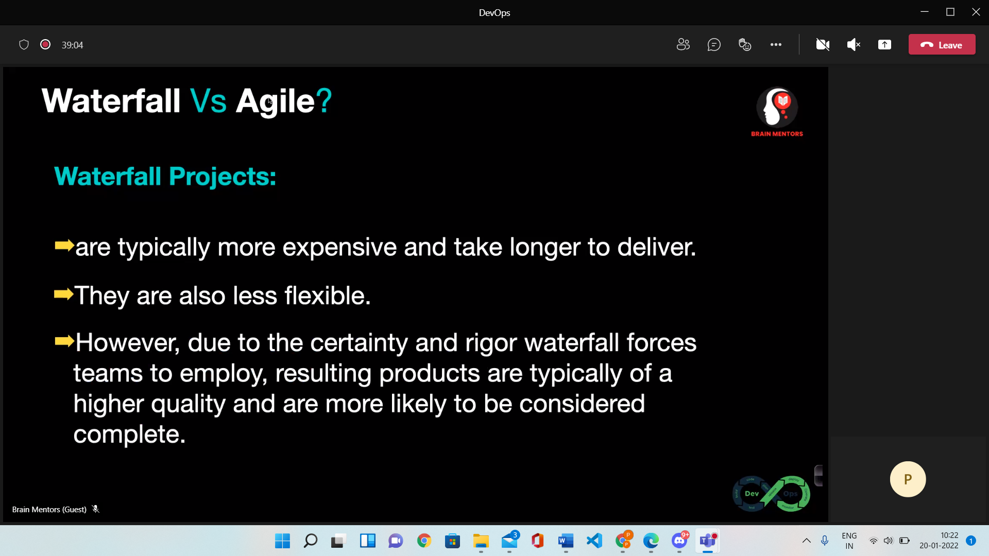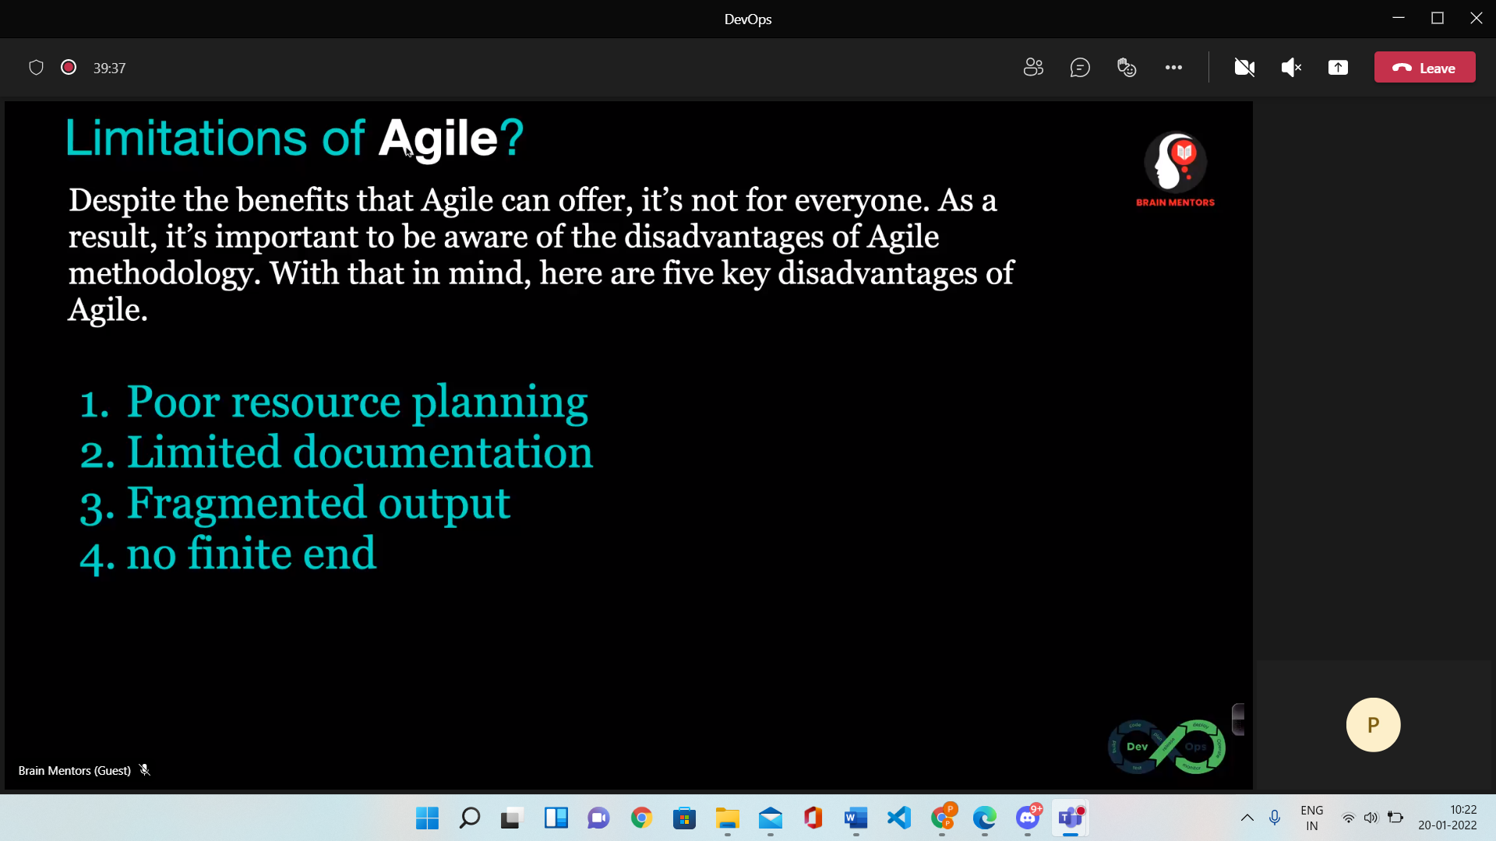

**What is DEVOPS**

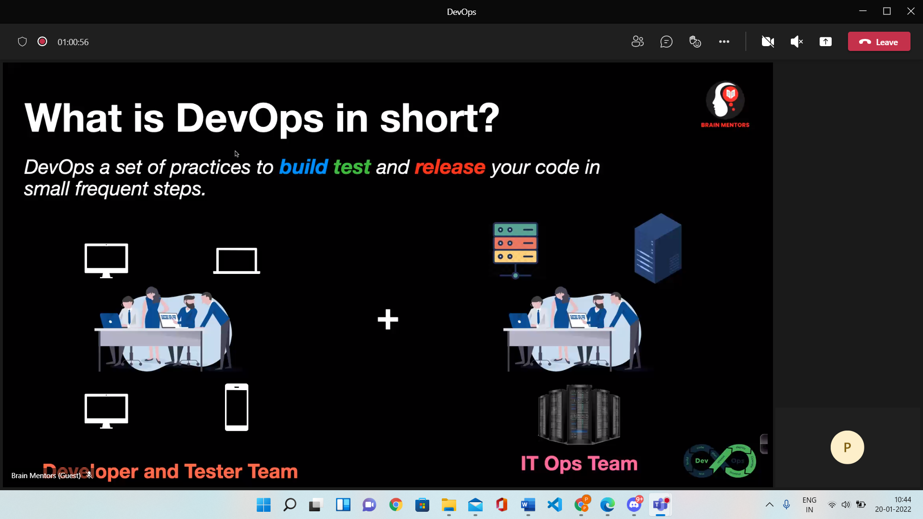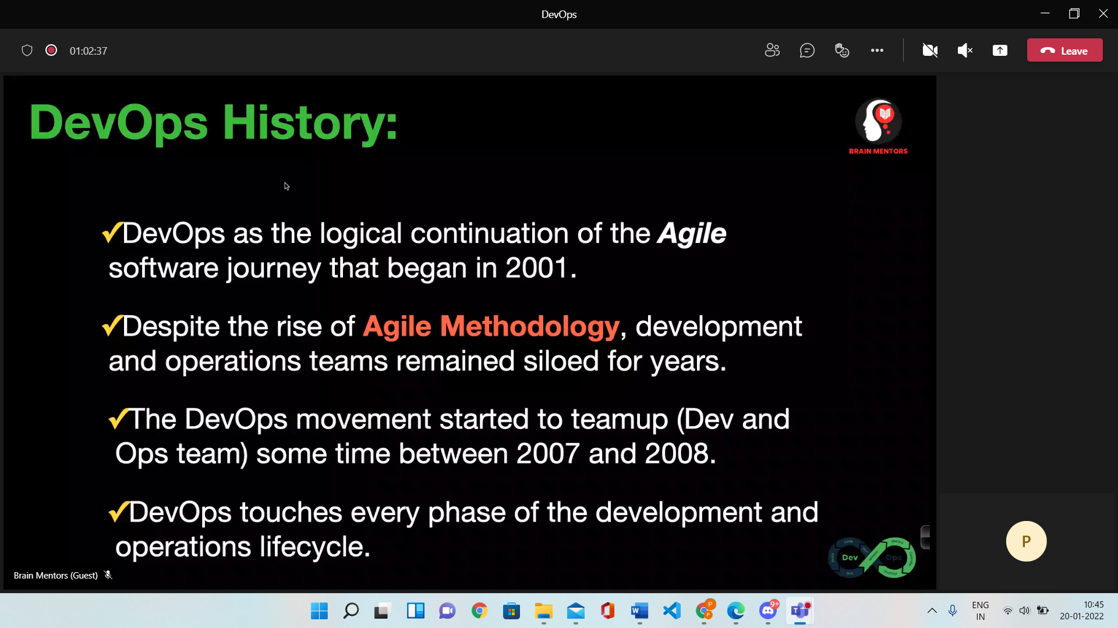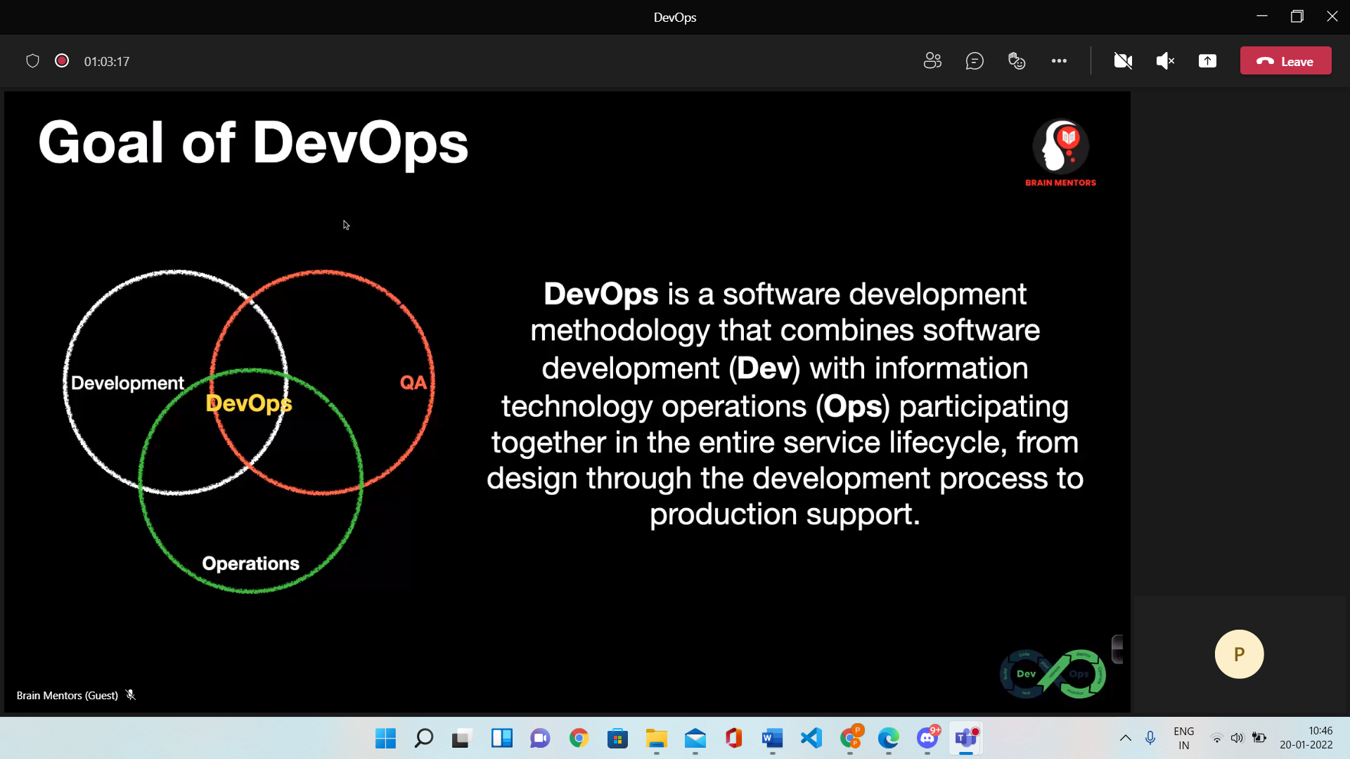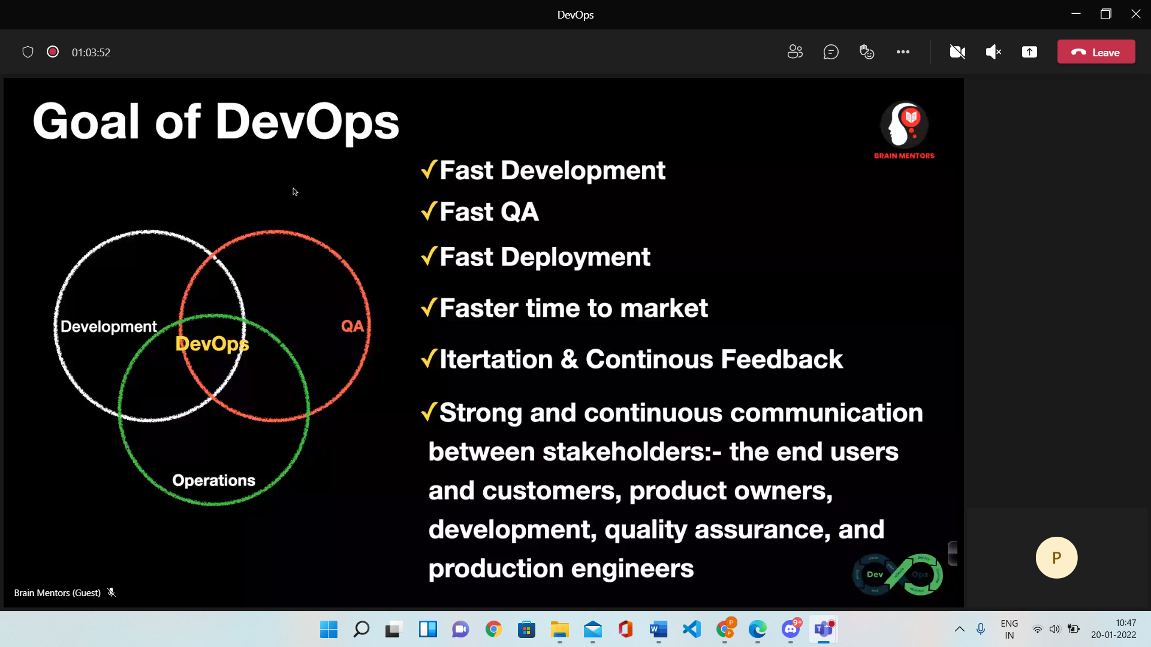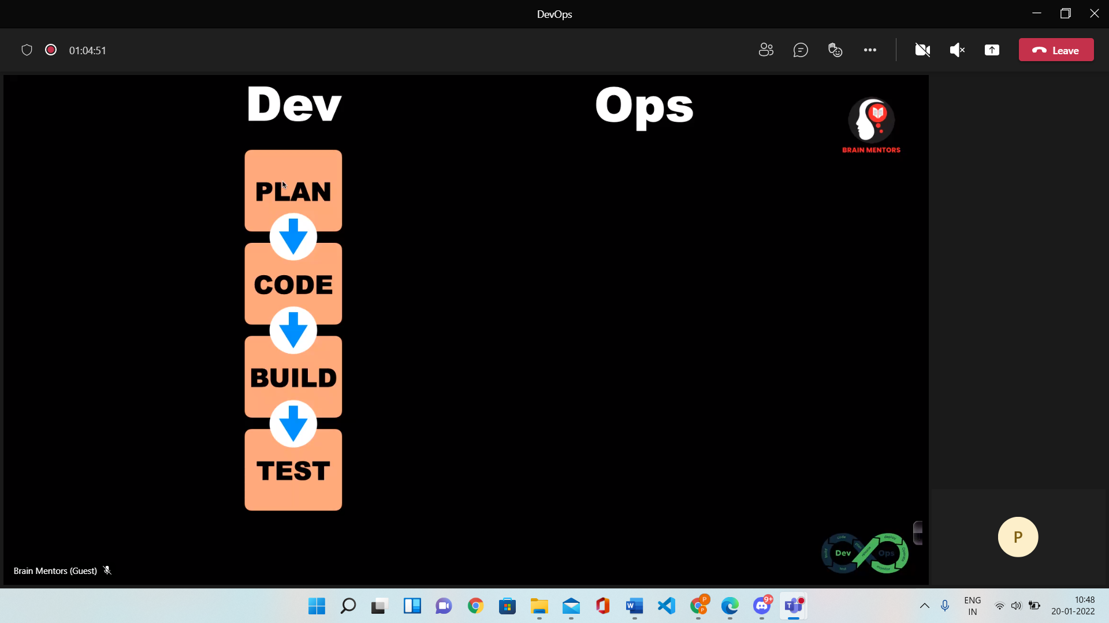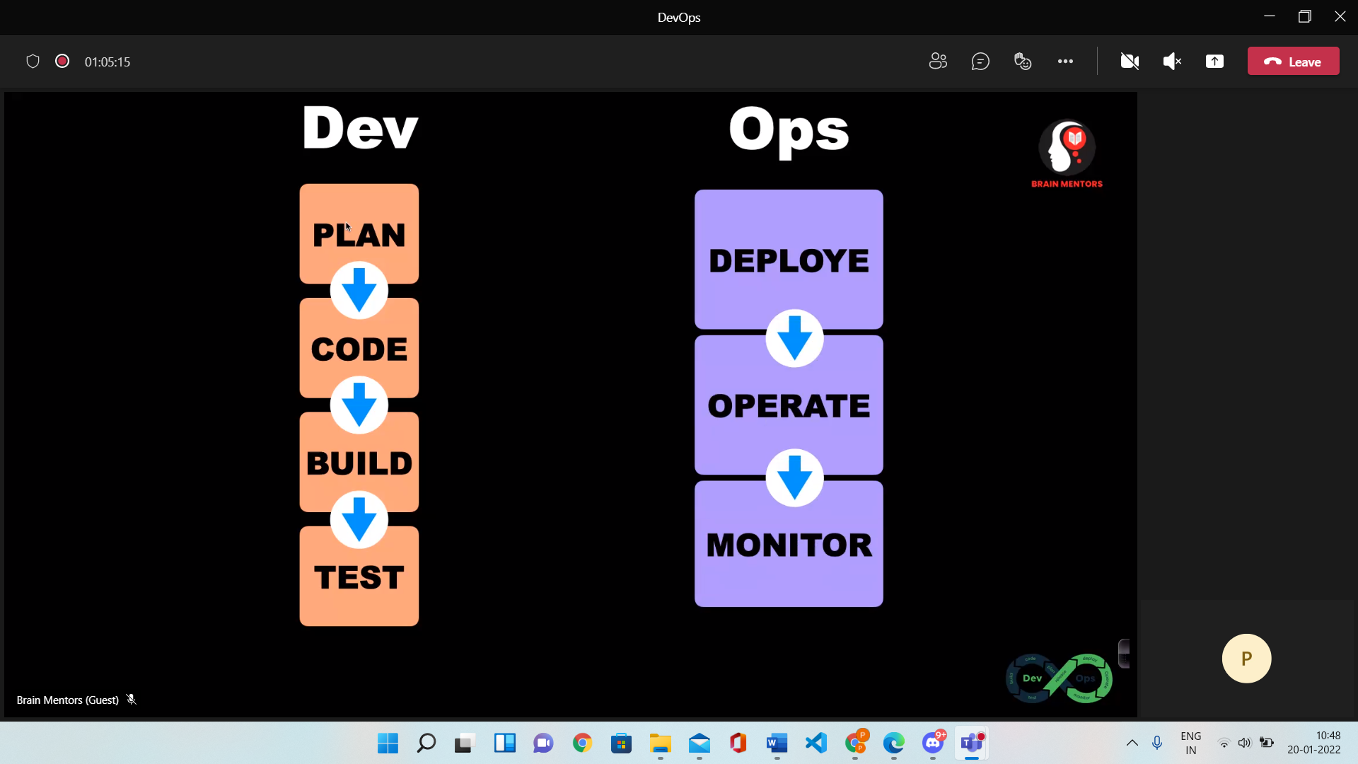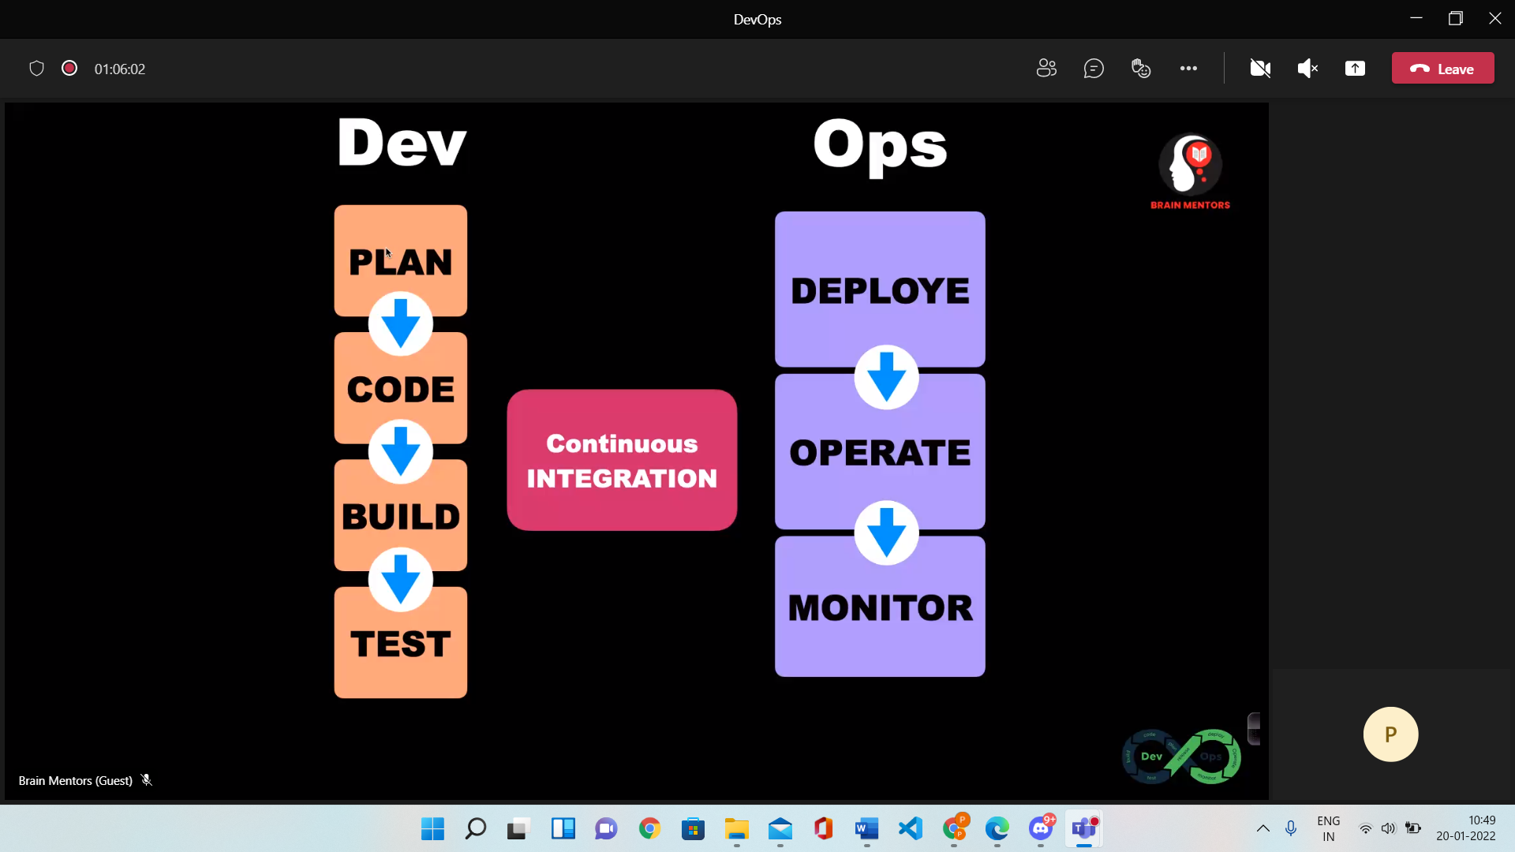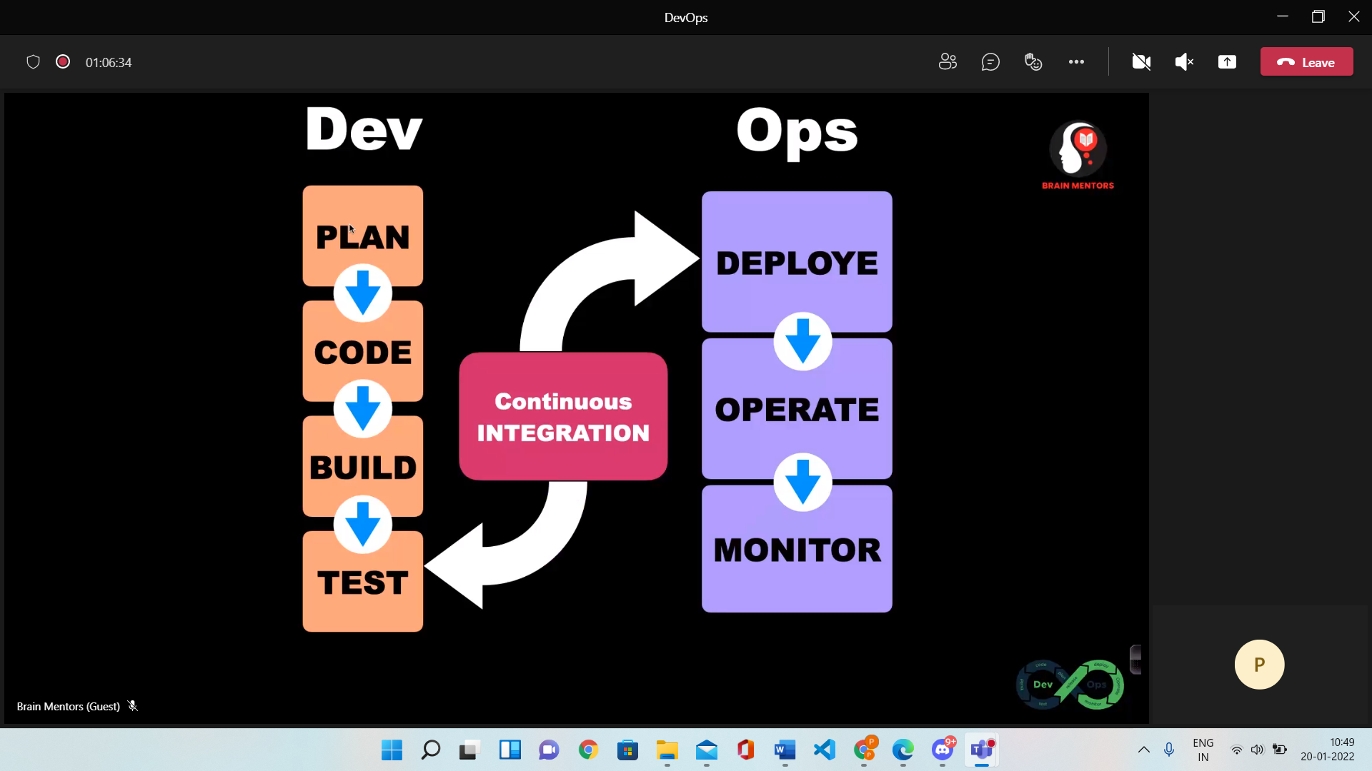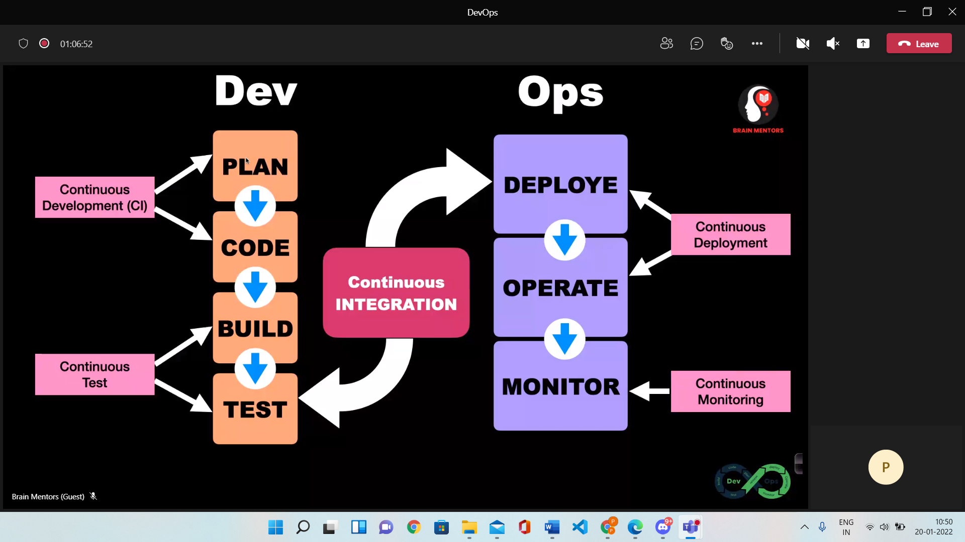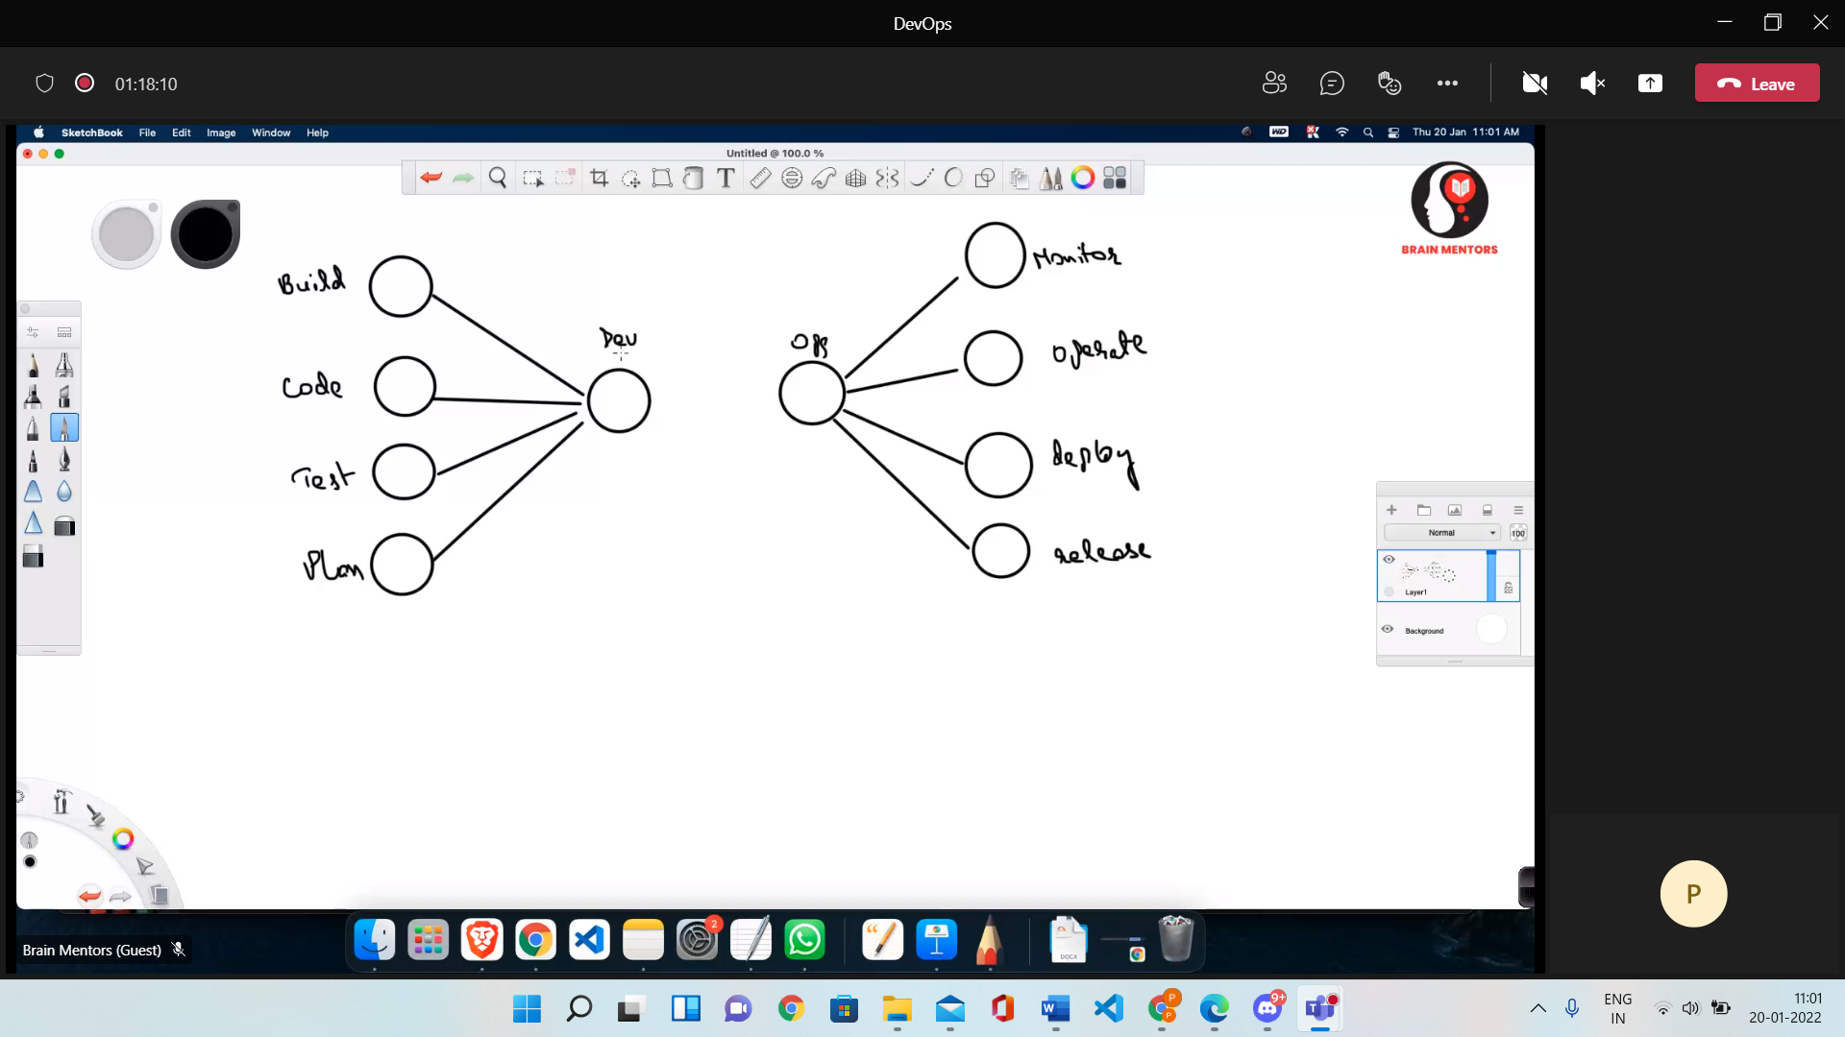

**Devops Lifecycle 🡪**

1. Continuous Development
   1. Plan and Code of the software (No Devops tools required)
2. Continuous Integration
   1. Heart of the Devops Lifecycle
   2. Changes Committed checked (Daily weekly bas)
   3. Includes Unit testing
   4. Integration Testing
   5. Code review
3. Continuous Testing
4. Continuous Monitoring
5. Continuous Feedback
6. Continuous Deployment
7. Continuous Operations

**Different Terms –**

1. Plan
2. Code
3. Build – Maven, Gradle
4. Test – Selenium, Test NG, junit
5. Integrate – Jenkins
6. Deploy – AWS, Docker
7. Operate -- Kubernetes
8. Monitor – Nagios, Elastic Stack

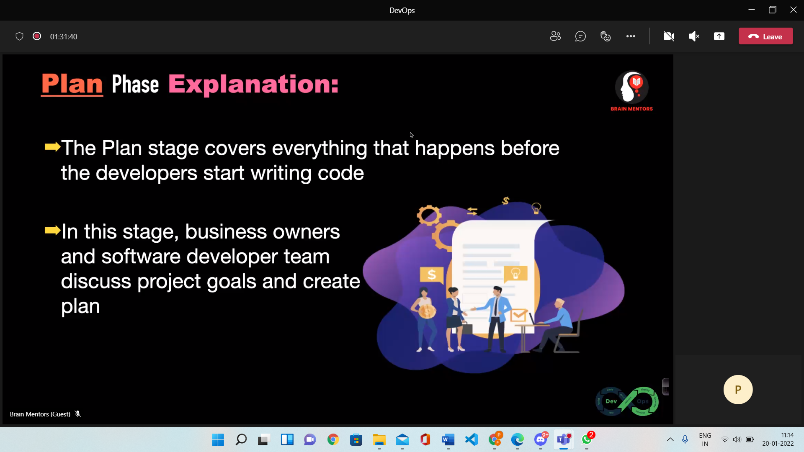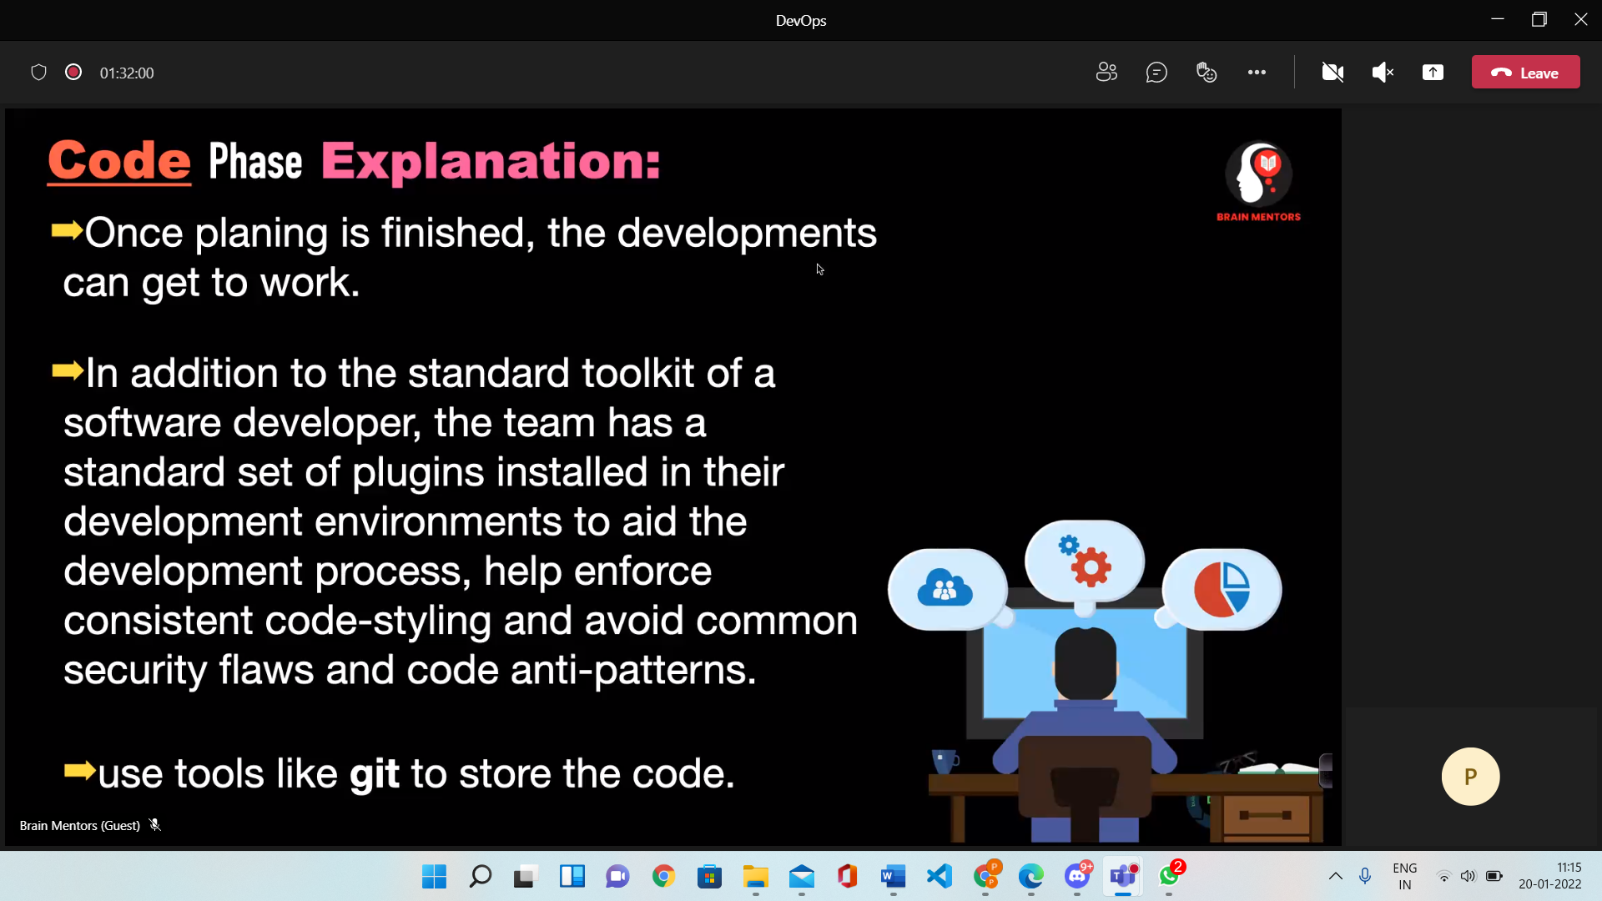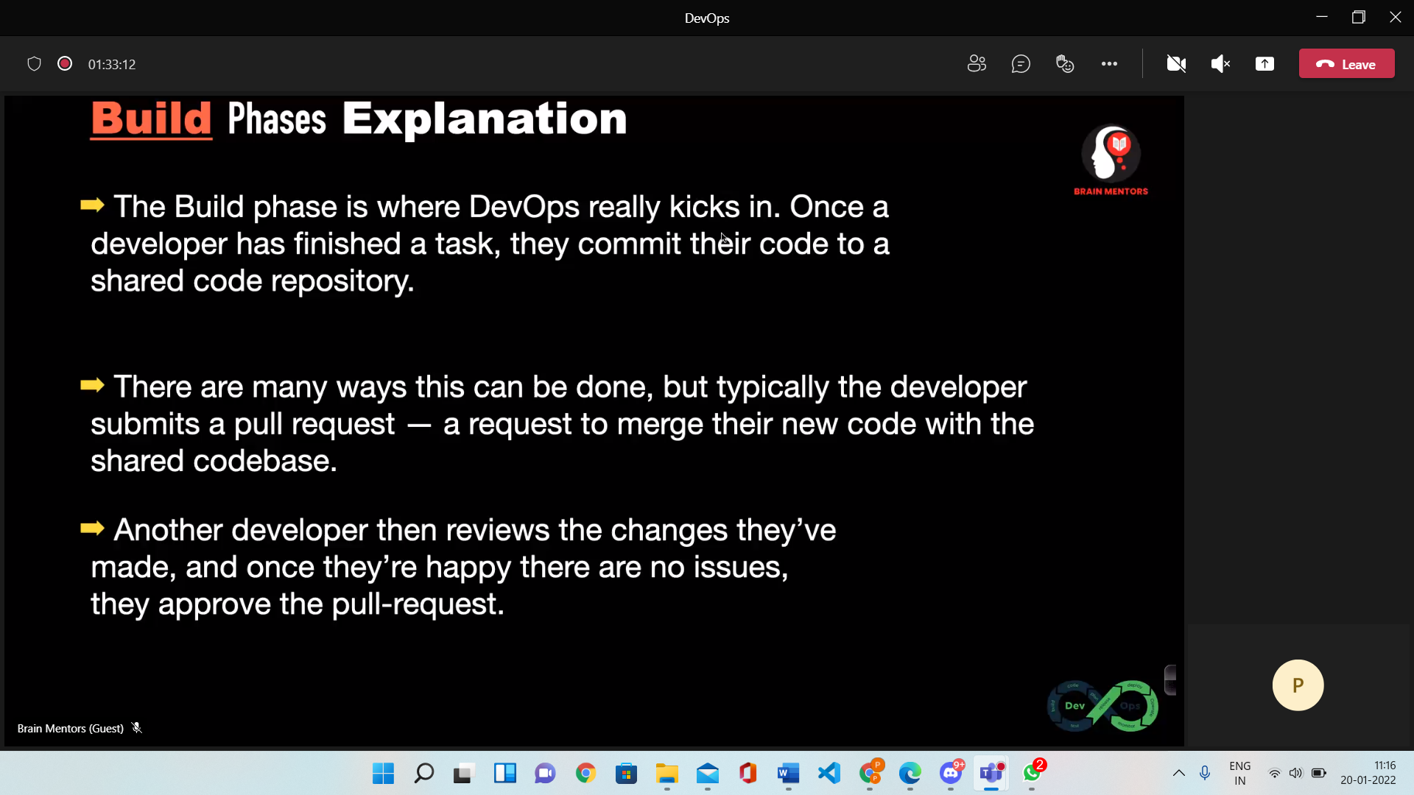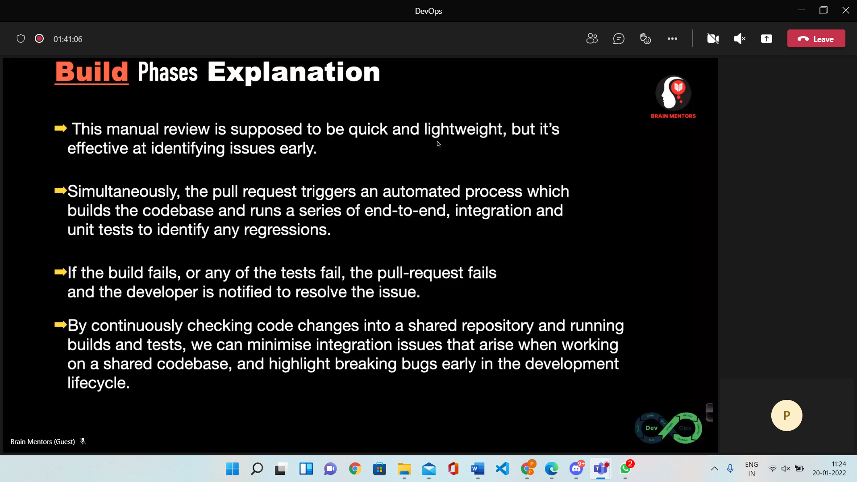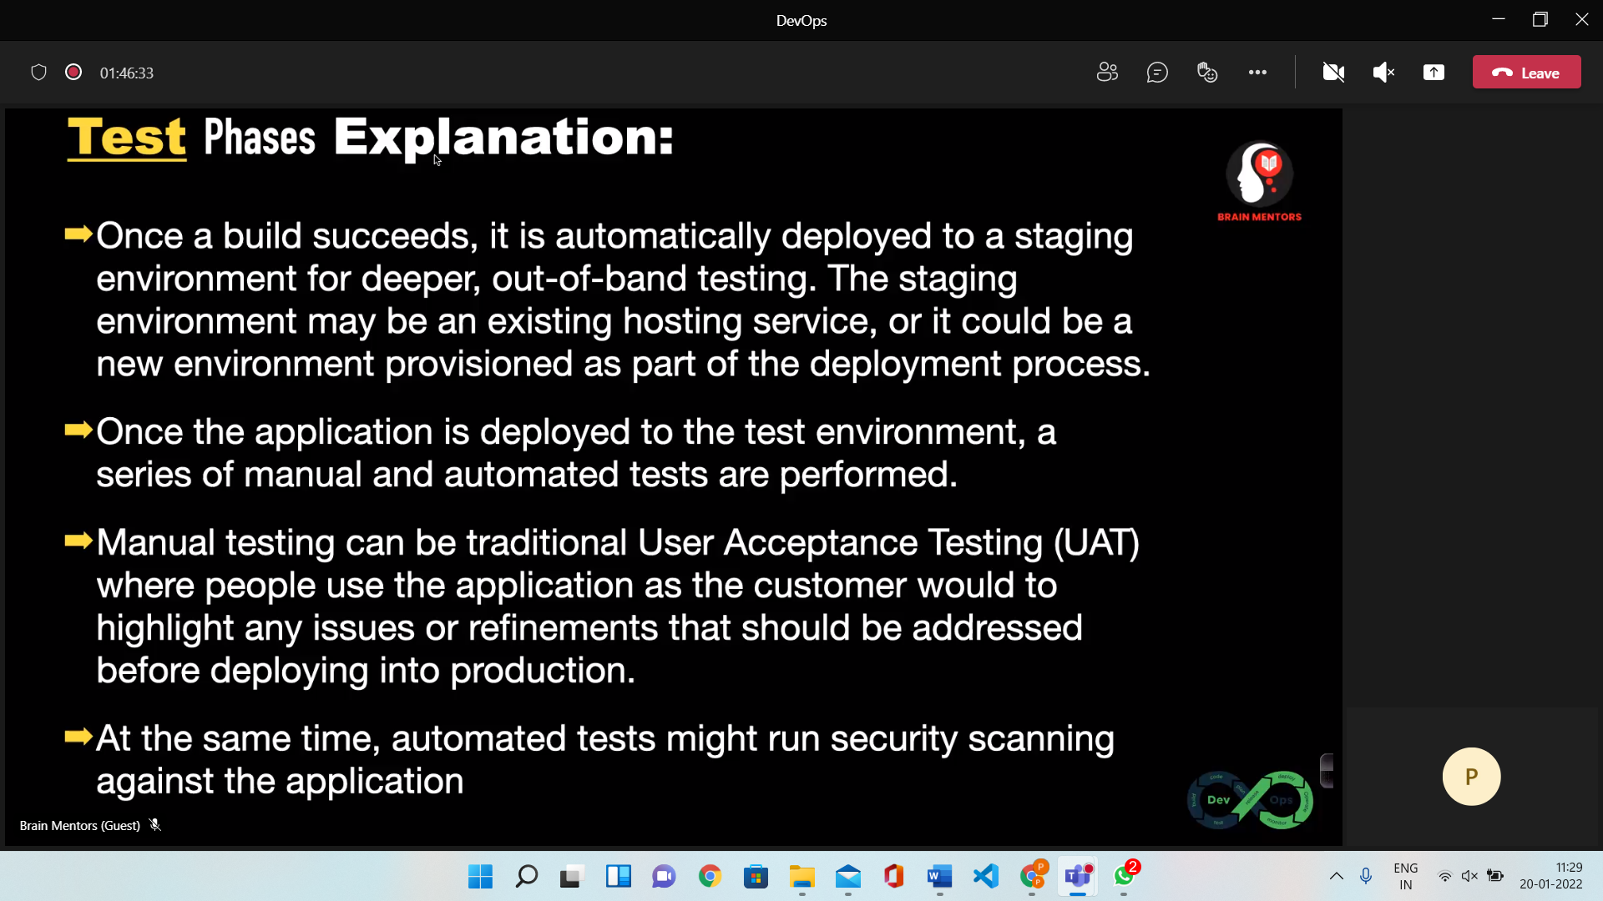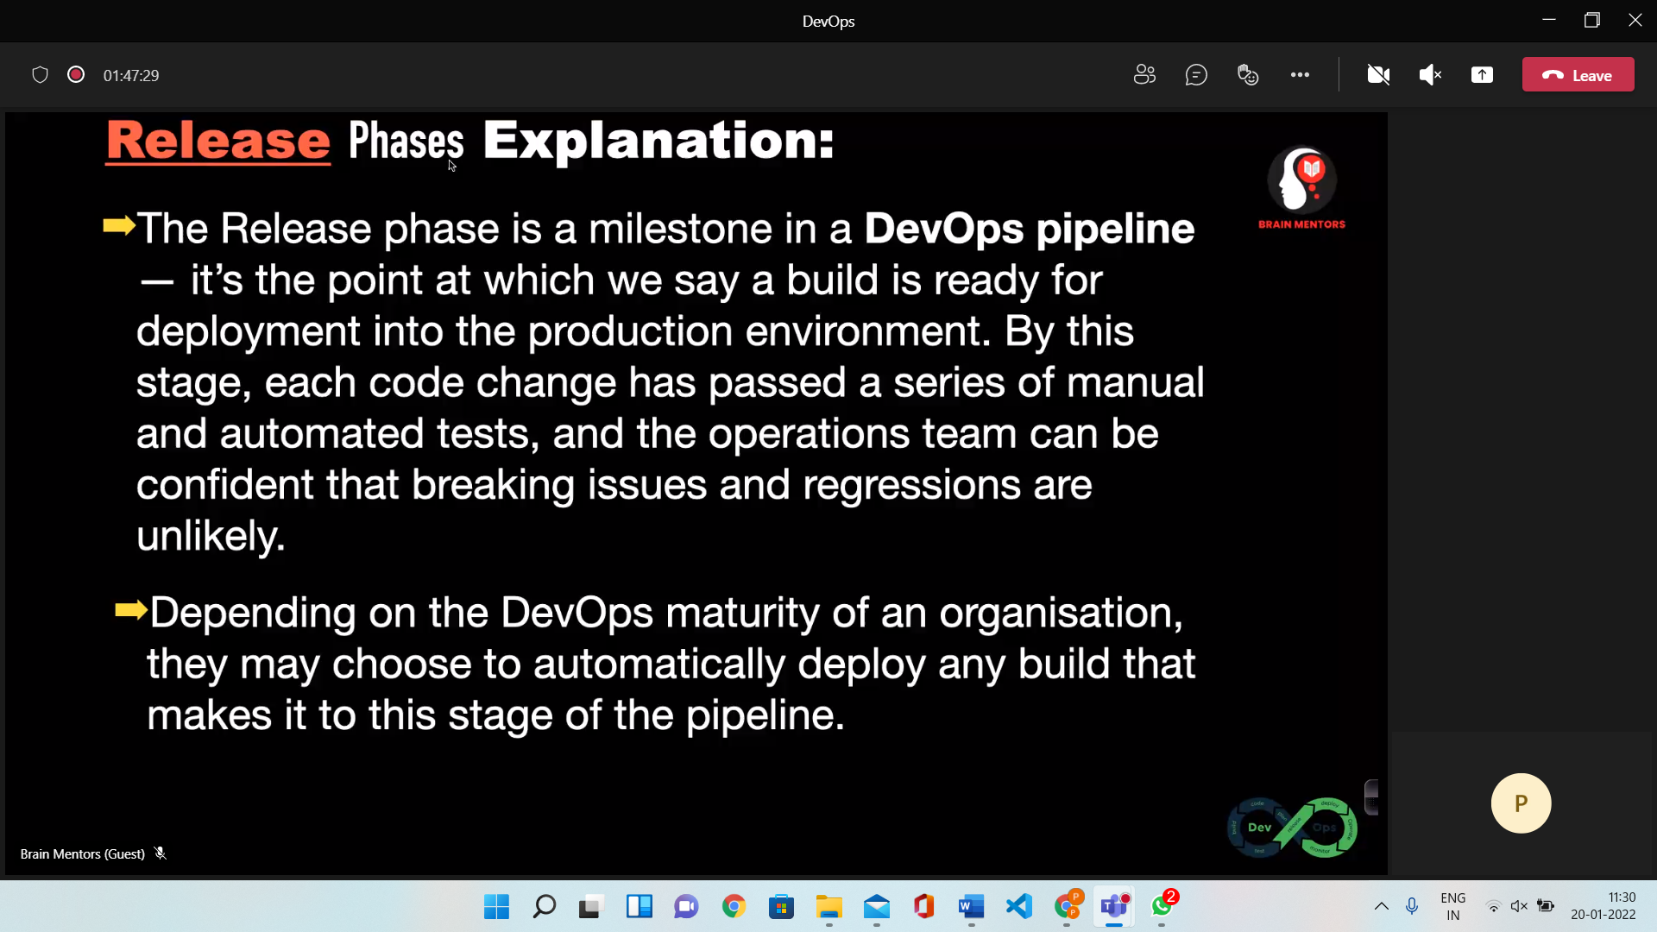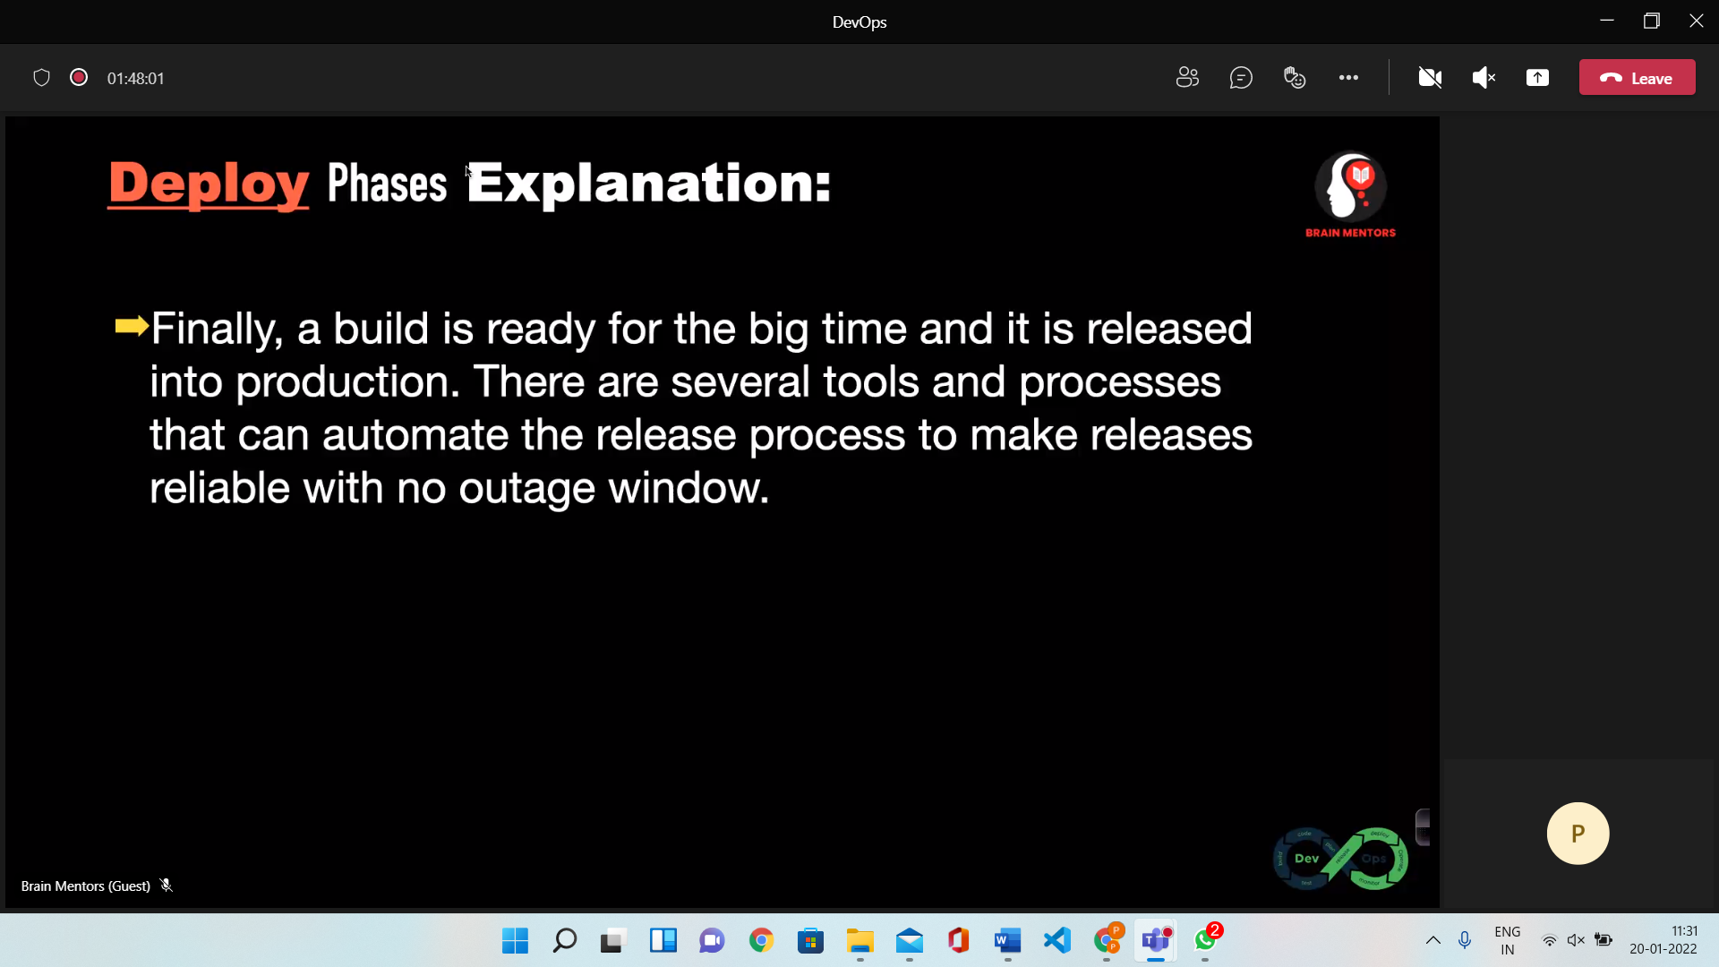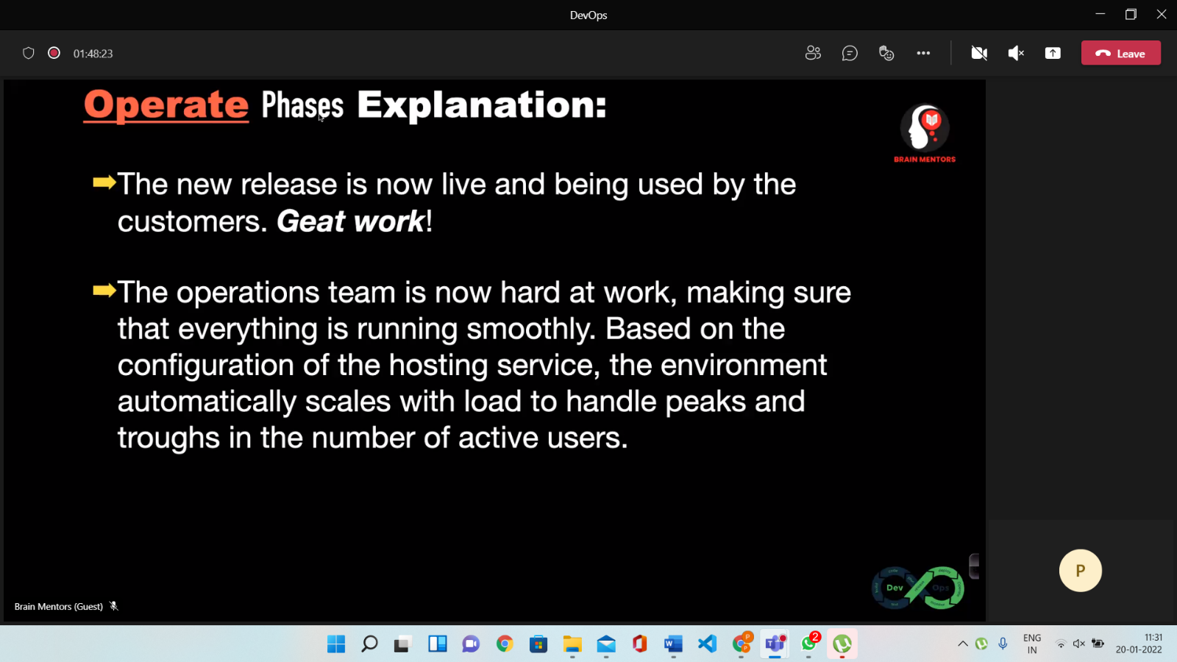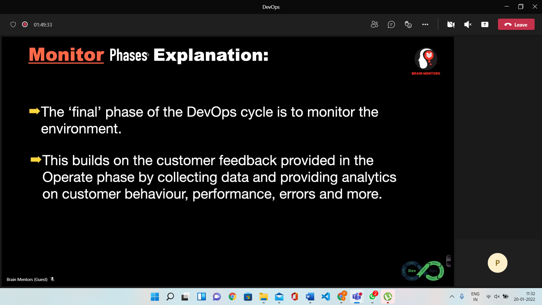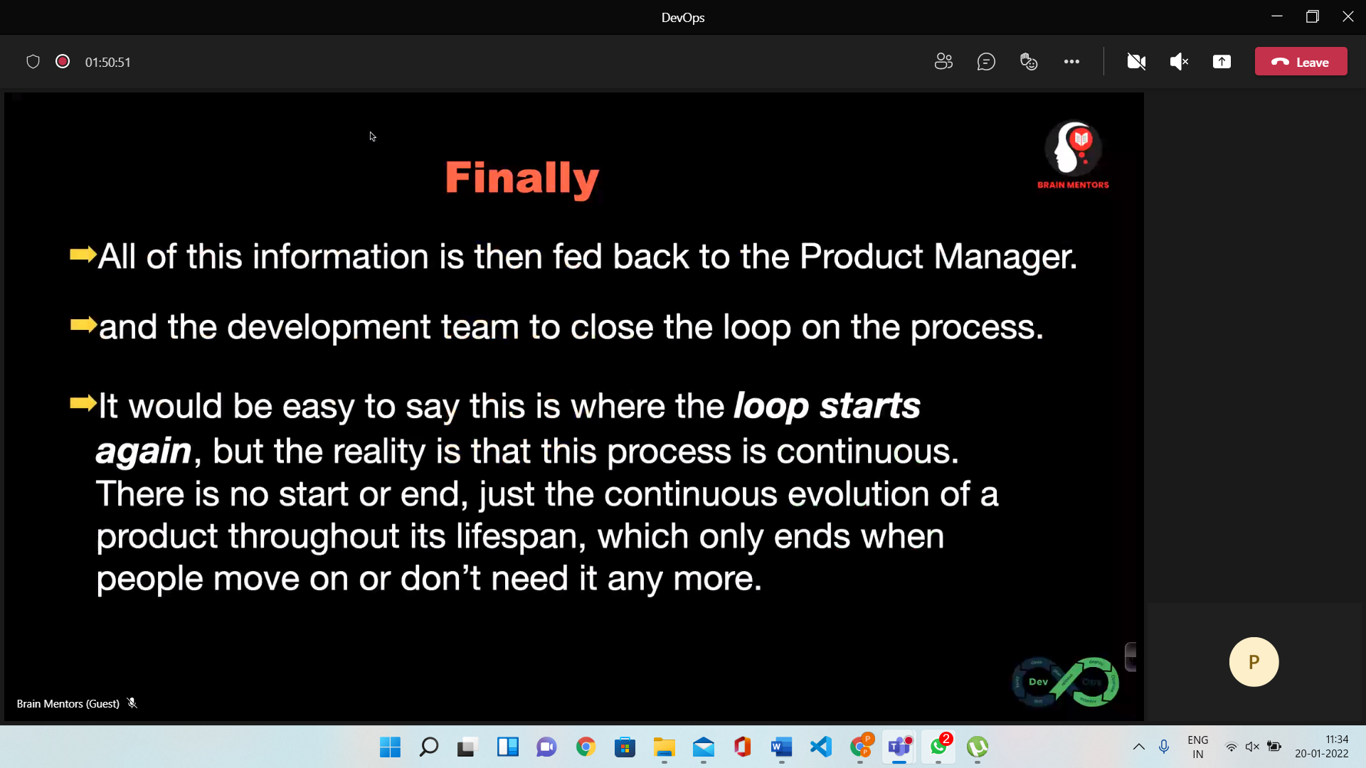

**Tools**

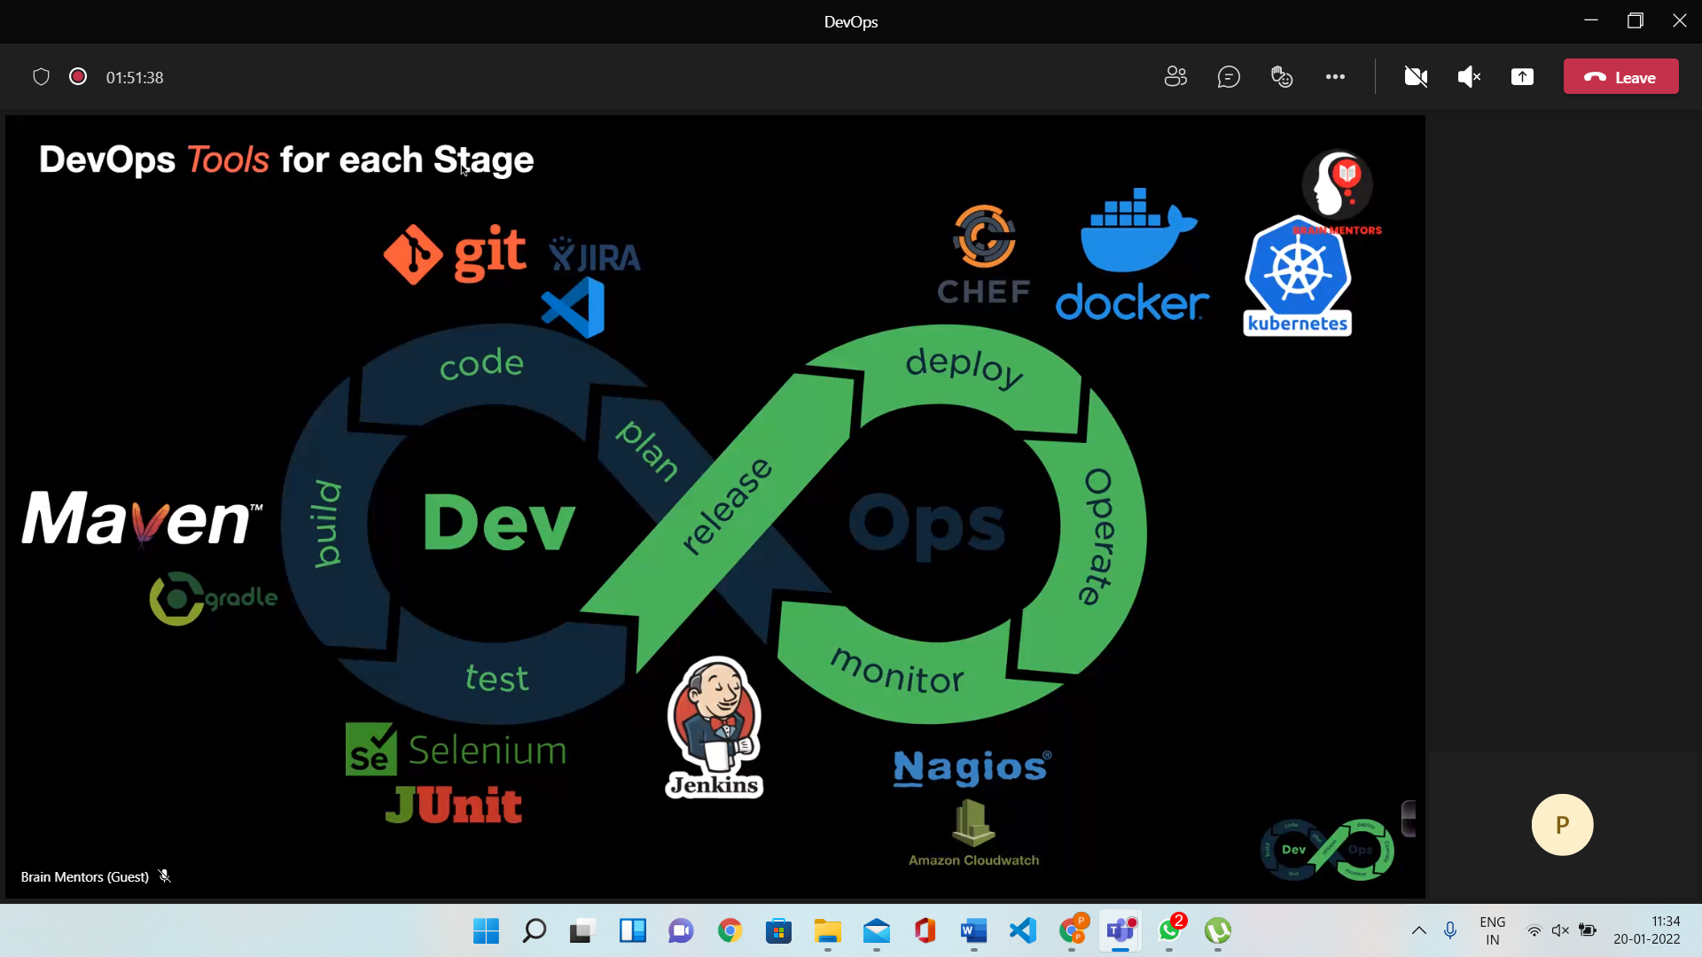

**Devops Process (CI (Continuous Integration)/CD (Continuous Development)**

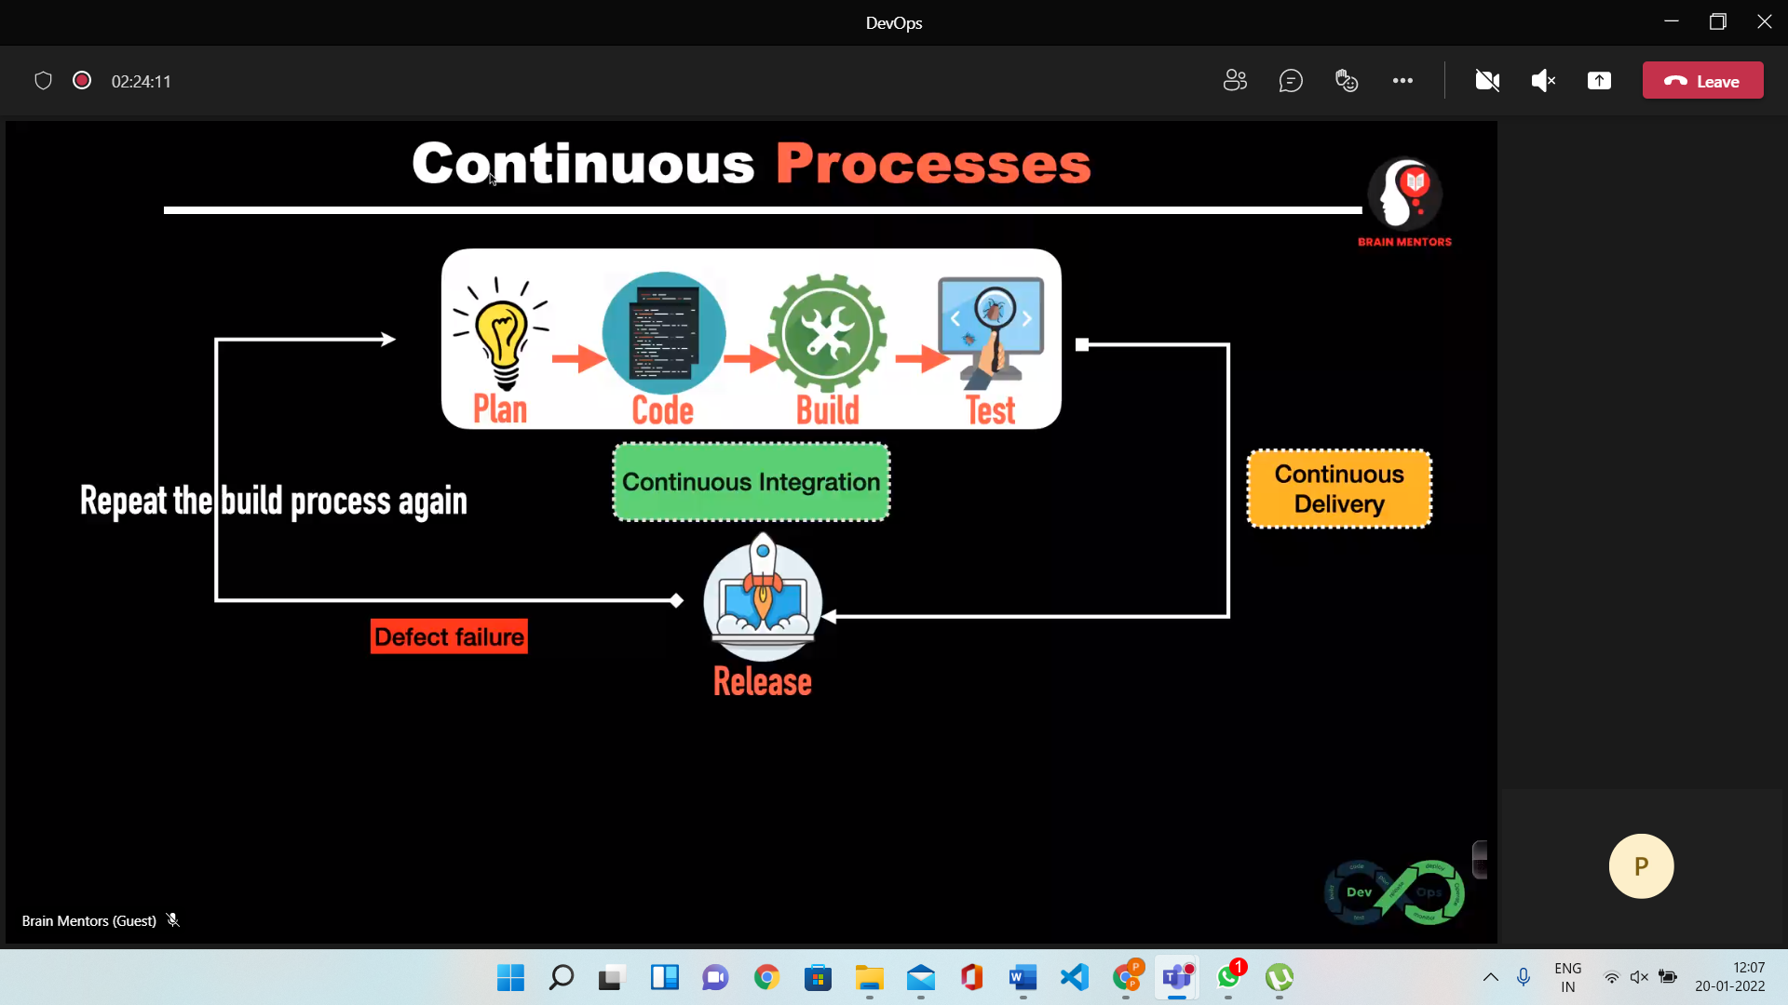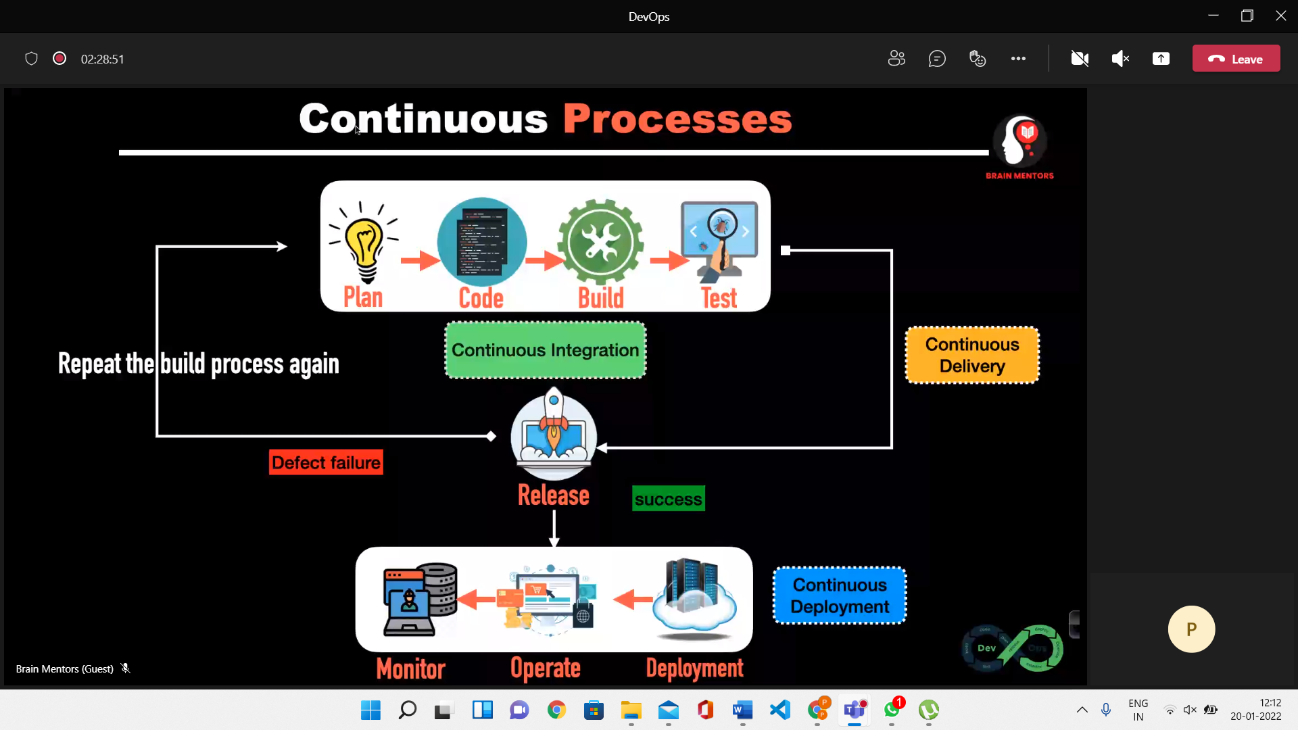

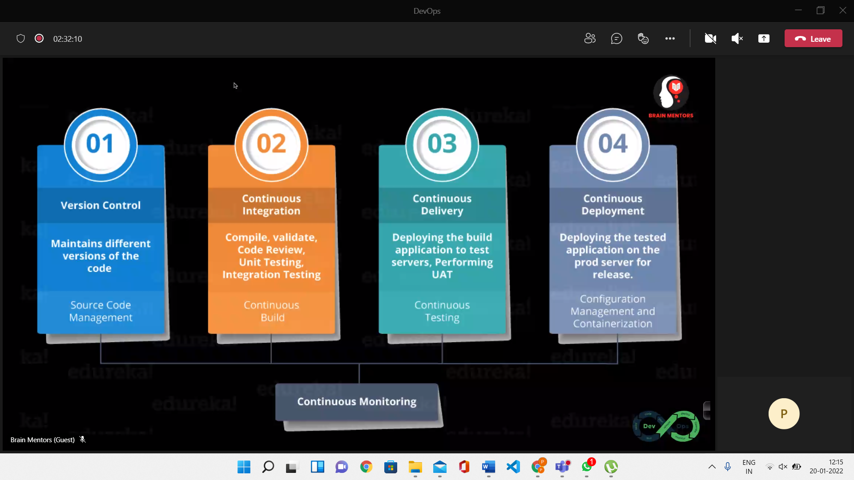

**Traditional Approach**

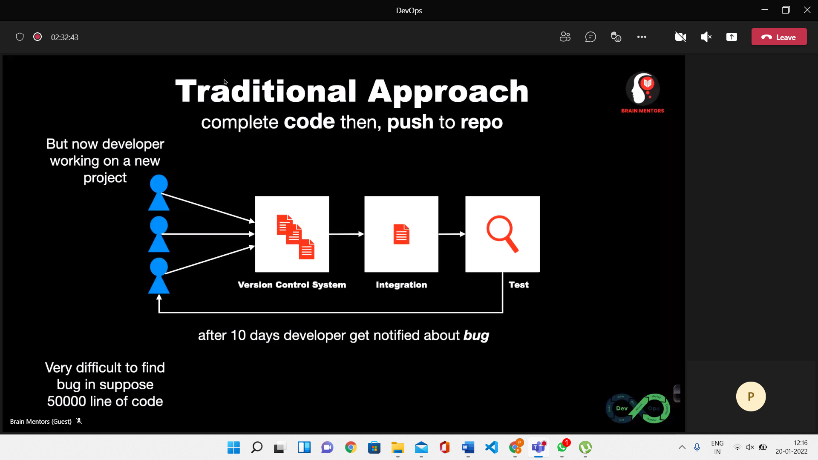

**Devops Tools**

* Junit
* Maven
* Gradle
* GIT
* SVN
* CHEF
* JIRA – Used to track issues – bug tracking
* Selenium – automation testing tools
* Ansible – Automate App Deployment
* Splunk
* Salt stack
* Bamboo
* Puppet – Delivery and Release
* Docker – Build Ship and Run
* Nagios – Identify Errors and Rectify them
* Jenkins – Monitoring the Execution of repeated Task – Continuous Integration
* Kubernetes